BLAENAVON
'Destiny's Mild'

New track revealed from their forthcoming ‘Miss World’ EP
out 30th October on Transgressive Records

LISTEN HERE

Announce new London Headline Show at The Lexington in Feb 2016
New shows announced with Foals and Oscar on upcoming UK tour
+ Forthcoming dates with Songhoy Blues, The Districts and Palace

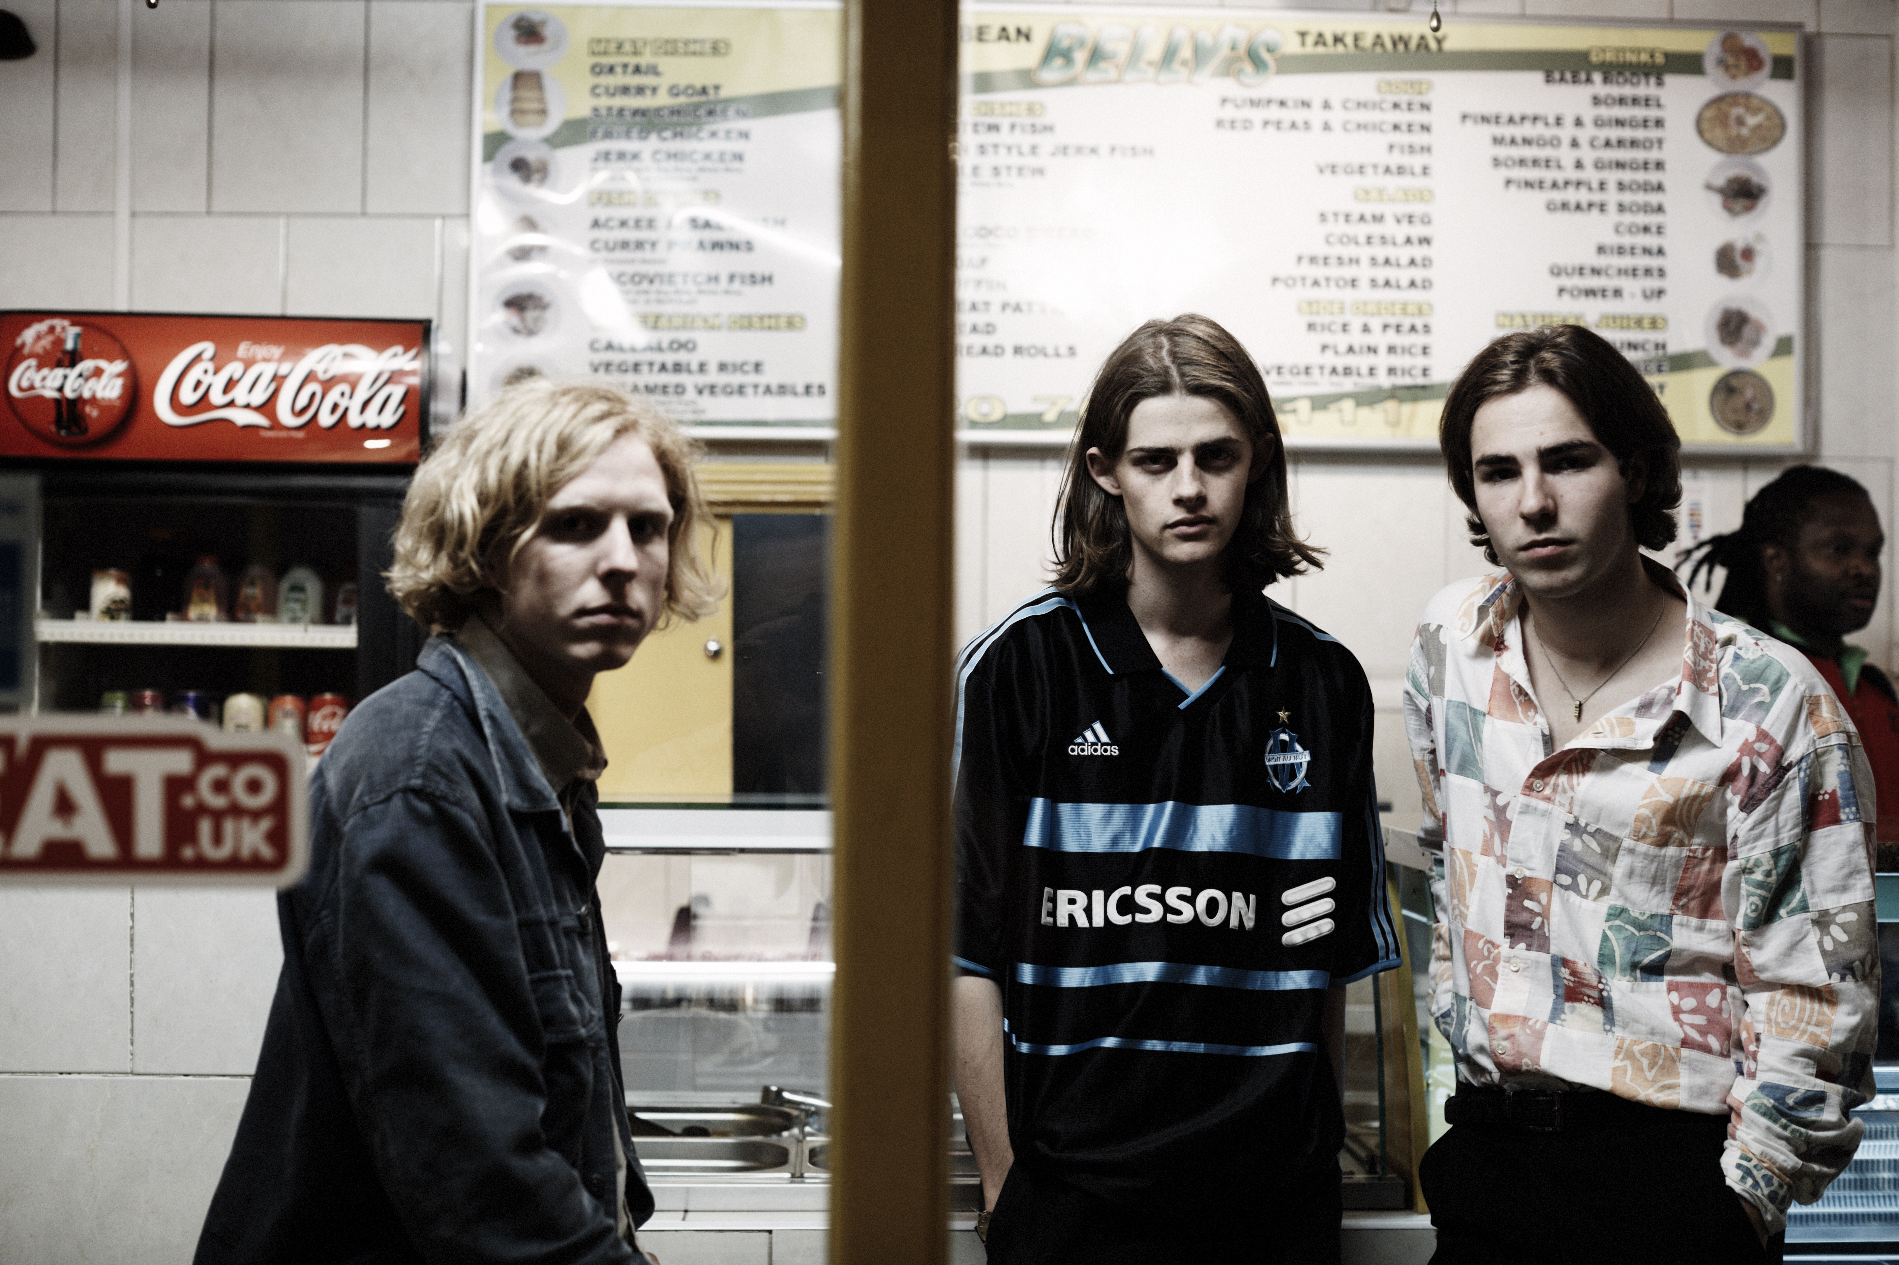
Photo Credit: Steve Gullick

"A mammoth slice of stadium-sized indie rock" - DIY
"Uncynical in a way that only a really young band can be." – NME
"Tightly wound, instantly accessible alt-pop that soars in all the right places." – The Line of Best Fit
"Buoyed with the sort of searing, soaring chorus most bands take a lifetime to perfect." – Clash

Blaenavon have unveiled ‘Destiny’s Mild’, a new song taken from their EP ‘Miss World’ released 30th October on Transgressive Records.

‘Destiny’s Mild’ showcases Blaenavon as one of the UK’s genuinely special bands and reflects the meticulous intelligence and ambition of these masterful writers. It follows recent track ‘Hell is my Head’, which has become an instant fan favourite, opening their live shows and receiving sweeping support from BBC Radio 1, Beats 1, BBC 6 Music, Radio X, Absolute and Amazing Radio.

Following a moshpit-infused, sell-out headline show at London’s Waiting Room as well as news of support dates with The Districts, Songhoy Blues and Palace, Blaenavon also announce a second headline London show at The Lexington on 4th February, plus a festival set at By The Sea with Foals. In addition, they will be taking to the road alongside Oscar for a five-night run as part of DIY Presents.

The ‘Miss World’ EP is produced by David Pye (Wild Beasts, Egyptian Hip Hop) and mixed by Dan Grech (Radiohead, Wolf Alice, Circa Waves), recorded during a school half term.

Released on Transgressive imprint paradYse two years ago, 'Into The Night' and 'Denim Patches' - the debut from Hampshire's Blaenavon - marked the teenage band out as one to watch. Before hitting legal drinking age, the boys played a series of sold out shows - including a more-than-memorable all ages gig at London’s Trinity Centre - and followed up with their debut EP KOSO which enjoyed support across BBC Radio 1 and 6 Music, plus nods from NME, DIY, The Line Of Best Fit, Wonderland, Rolling Stone and Clash.

Blaenavon’s line-up is; Ben Gregory (Vocals. Age 19), Frank Wright (Bass. Age 19) and Harris McMillan (Drums. Age 19).

Blaenavon Live Dates

21st Oct – Brighton - Green Door Store w/ Palace
22nd Oct – Glasgow – SW3 Warehouse Studio w/ Songhoy Blues
23rd Oct – Leeds – Brudenell Social Club w/ Songhoy Blues
25th Oct – Manchester – Gorilla w/ Songhoy Blues
26th Oct – Birmingham – Hare & Hounds w/ Songhoy Blues
27th Oct – Bristol – The Fleece w/ Songhoy Blues
3rd Nov – Brighton – Concorde 2 w/ Songhoy Blues
4th Nov – London – Koko w/ Songhoy Blues
11th Nov – London – Electric Ballroom w/ The Districts
14th Nov – Margate – By the Sea Festival w/ Foals
16th Nov – Cardiff – Clwb Ifor Bach w/ Oscar
17th Nov – St Albans – Horn w/ Oscar
18th Nov – Newcastle – Head of Steam w/ Oscar
19th Nov – Leeds – Brudenell Games Room w/ Oscar
20th Nov – Manchester – Fallow Café w/ Oscar
29th Nov – Brighton Mutuations Festival

4th Feb – London – The Lexington
(Headline Show – Tickets: www.rockfeedbackconcerts.com)

Pre-order Miss World Now

Limited edition vinyl: shop.transgressiverecords.com
iTunes: https://itunes.apple.com/gb/album/miss-world-single/id1039318487

https://soundcloud.com/blaenavon
www.facebook.com/blaenavonmusic
www.transgressive.co.uk

For further information please contact sarah@bleachedcommunications.com

