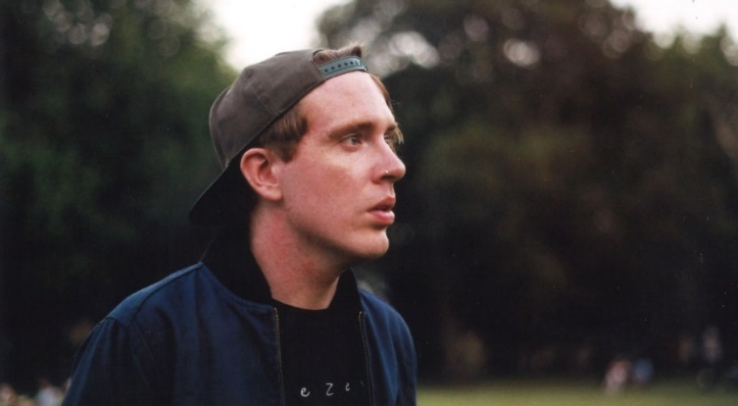

LISTEN HERE: https://soundcloud.com/gingersnapspop/sets/finished/s-ySnNU

“Baggier than a vintage shop’s sale rail and laced in all manner of swirling psych, Ginger Snaps’ breakbeat pop is as flexible as they come."
DIY

“Ginger Snaps dwells in slacker climes, matching fuzzed up riffs against boom-bap hip-hop beats. Re-calls everyone from Beck to De La Soul, but really it could only come from the mind of a certain Northampton dweller”
CLASH

"If there's a band that's needed right now its Ginger Snaps; melding oldskool hip hop breaks with modern day pop sensibilities”
BBC Introducing

Ginger Snaps is multi-instrumentalist singer and producer Jay Brook from Northampton. Whilst also being a main writer for the Radio X play-listed OhBoy!, Jay & his writing partner Lee Irons have spent time in their Northampton Lab cooking up a brand new sound.

Beginning in April 2015, Jay & Lee set out on a new musical adventure, a recipe they'd been eager to debut for years through various musical endeavours but finally felt ready to showcase.

First out the door came debut 'Paranoid' in May, a raucous, funk laden record, drenched in baggy instrumentation and groove effects, made pristine through Jay's self-aware commentary and gritty vocals.

CLASH were quick to premiere the track and Radio X were made fans – adding it straight onto the Evening List. Radio 1’s Huw Stephens added it to his BBC Introducing Playlist, 6Music’s Tom Robinson put it on his BBC Intro Mixtape and BBC Northampton brought Jay in to talk about his sudden ascension!

‘Phat Kids’ became the bold second single when released in July - where Jay received further high praise from DIY & Radio 1's Annie Mac - at which point she made Ginger Snaps one of her esteemed August #NewNames. Amazing Radio whacked it on its A-List – climbing into the Top 10 of the Amazing Chart. Sofar Sessions wanted to see it played live.

This follow up single, filled with social commentary wrought with wit and angst, explores Jay’s anxious curiosity into self-obsession and self-critique. Ginger Snaps continues to develop that trademark slacker delivery.

A Ginger Snaps live show debuted when Radio 1's Abbie McCarthy asked the band to play her monthly Good Karma Club in Islington in September, a refreshingly different live set up involving parts of a gospel choir and a veteran scratch DJ.

Phat Kids has just been re-released stateside courtesy of ECG Records (Gaslight Anthem, Twin Atlantic) & new single Number Crunching is due in February in the UK via the incredible Killing Moon Records (Bad Sounds, April).

Keep up to date with all things Ginger Snaps over at his socials:
Facebook
@GingerSnapsPop
MGMT: cullenkieran@gmail.com

