GOLD PANDA

- SHARES NEW TRACK & VIDEO ‘IN MY CAR’

- ANNOUNCES MORE LIVE DATES

- NEW ALBUM ‘GOOD LUCK AND DO YOUR BEST’
TO BE RELEASED ON MAY 27TH VIA CITY SLANG

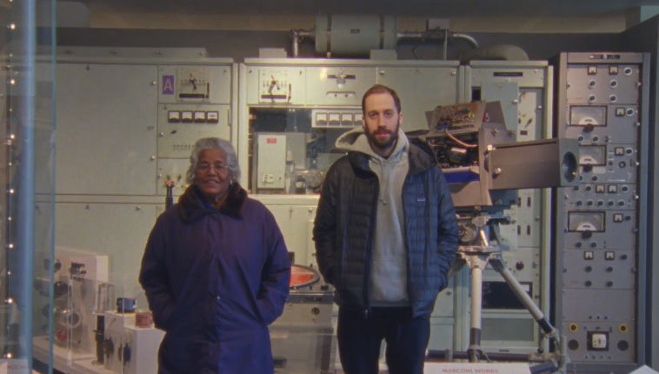

After recently announcing his upcoming album ‘Good Luck And Do Your Best’, due 27th May via City Slang, Gold Panda is sharing the second single from the record, ‘In My Car’, online now. Gold Panda has also announced more UK live dates, in addition to the headline London show on 30th May.

Filmed by Rob Brandon, the ‘In My Car’ video was shot in Gold Panda’s hometown of Chelmsford and portrays an intimate look into the life of the producer, starring non-other than his grandmother, Lakhi Shiner.

Gold Panda said “I asked Rob to just come and film us (my gran and I) being boring. But now, when I watch it back, it doesn’t seem mundane at all. It seems actually really nice and sweet. I was thinking about all this cool stuff we could do, slow-mo shots, what outfit I could wear, maybe an explosion and who could be in my crew. But real life is exciting enough; you just don’t see it when you’re in it.”

Rob spoke about what he wanted to get across in the video when he said “I think Derwin and myself are both in an artistic place that is quite real and honest and appreciative and we wanted to shoot a film that reflects that. We both have an odd relationship with Chelmsford and we tried our best to try capture that without being contrived about it.”

Watch the ‘In My Car’ video: https://www.youtube.com/watch?v=6YVhAILmqyo

‘In My Car’ on soundcloud:
https://soundcloud.com/goldpanda/in-my-car/s-LLbmT

Gold Panda has also announced a series of live shows, including a London album release show in May plus UK and European summer festival appearances including London’s Field Day– details below.

'Good Luck And Do Your Best' was initially planned to be something else entirely. Early in 2014 the electronic artist most comfortable with the moniker Derwin Panda set out to Japan for the first of a pair of trips – the latest of many visits to a place he holds most dear. This time a photographer, Laura Lewis, accompanied him as Derwin’s plan was to collect both audio field recordings from his trip across the country as well as accompanying visuals, with Laura tasked to capture what they saw and encountered together. The idea was to be able to put together something other than a traditional record; a sight and sound documentary of his time there, but the expedition ended up being the catalyst for a new record.

It began with an album title. “Halfway through the first trip we bought rail tickets and rode across the country and went to Hiroshima”. Derwin explains. “One afternoon we had taken a taxi, and as we got out, the Japanese taxi driver’s parting words to us as we left, were ‘good luck and do your best’.

“It was [the driver] speaking in English. He didn’t know English that well, but there’s a Japanese phrase called ‘ganbatte, kudasai’. And roughly translated, it basically means ‘do your best’, or it can also mean ‘good luck’.”

As a result of that chance interaction, Derwin says, he had the title for an album as well as a starting basis for the music. “Once you have a title, for me, things come together a lot easier for what it’s going to be.” Struck by the phrase, he ended up being led by the experience to make a record that is, to him “quite motivational, quite positive.”

Sonically, Derwin characterised the record by way of the visual inspiration he took from his Japanese trips. “I went over twice. Once in April, once in October, and they’re the best times to visit, because the weather is calm - it’s not too hot or too cold.”

“The album was recorded at home in Chelmsford, but I had that visual inspiration or documentation from Japan. So it was a look back. If you go in those months, Japan has this light that we don’t get here. It’s hard to explain. You know how LA has this dusk feeling? - that orange light that makes the place glow, and the neon signs? Well, Japan has this… at certain times of the year, it has this filter on stuff. So when we went the first time, there were a lot of pink and green colours. Mainly the buildings and cars and the people, and I think Laura captured those colours really well.”

Those sights and colours translated to a record that differs notably from his previous album, ‘Half Of Where You Live’. Whereas that record was occasionally taut, perhaps harder and more piecing, the 11 songs that comprise ‘Good Luck And Do Your Best’ have a distinctly warmer palate, one that echoes ‘Lucky Shiner’ a little more, albeit with a clearer range of sounds, and also, to Derwin’s mind, one where “the tracks aren’t popping out against each other. It’s a [complete] record.”

Having finished recording his album, Derwin took the songs to fellow musician and producer Luke Abbott, wherein Luke “made it sound good, he put it into his magic smelter”, Derwin laughs. Mixing it at Luke’s studio, which similar to Gold Panda’s place of work, resides in his parent’s house in Norwich, reinforced the nature of the record in Derwin’s mind. “It has a homely feel. The tracks were made at home and they were mixed at Luke’s studio, so throughout the process, there’s always been access to family and your local surroundings. And banana bread.”

'Good Luck and Do Your Best' is Gold Panda at his most relaxed & confident. Doused in a chalky Japanese-inspired haze and underpinned with a positivity & strength of conviction founded in being created amongst familiar settings & routines, it’s a record that is explorative and expansive, yet hearteningly warm & familiar.

“You don’t control the music you make. The tracks need to reveal themselves”, Derwin muses. “Personally I don’t think I can choose to make it how I want.” But whether the 12 tracks that make up 'Good Luck & Do your Best' found him, or he found them, the result is a definitive & decisive chapter in Gold Panda’s trilogy: an album of vivid imagery & colour.

'Good Luck and Do Your Best' is to be released on May 27th via City Slang worldwide and is available for pre-order at https://goldpanda.lnk.to/gladyb and http://smarturl.it/GoldPandaLabel.

'Good Luck And Do Your Best' tracklist:

1. Metal Bird
2. In My Car
3. Chiba Nights
4. Pink And Green
5. Song For A Dead Friend
6. I Am Real Punk
7. Autumn Fall
8. Halyards
9. Time Eater (video) (stream)
10. Unthank
11. Your Good Times Are Just Beginning

Good Luck And Do Your Best artwork:

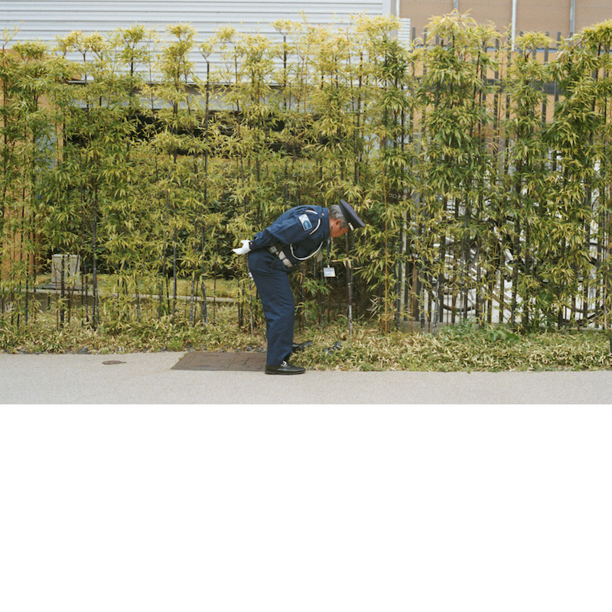

Gold Panda tour dates:

April
1 - UK - Norwich - Arts Centre
May
19 - Italy - Rome - Spring Attitude Festival
26 - UK - Leeds - Brudenell Social Club
28 - Netherlands - Amsterdam - Marktkantine
30 - UK - London - Tufnell Park Dome
June
1 - USA - New York - Bowery Ballroom
2 - USA - Los Angeles - Echoplex
11 - UK - London - Field Day Festival
16 - Spain - Barcelona - Parc del Forum
19 - Ireland - Dublin - Body & Soul festival
July
8 - Italy - Milan, Magnolia
9 - Italy - Ferrera, Festival
15 - Germany - Berlin - Melt Festival
17 - Belgium - Dour Festival
19 - Spain - Ibiza - Pacha
29 - UK, Hertfordshire - Standon Calling
30 - Denmark - Copenhagen - Trailer Park Festival
August
27-28 -USA - FYF, Los Angeles

Links:
Gold Panda Press Photo
Gold Panda Pre-Order Link
Gold Panda on Facebook
Gold Panda on Twitter

For more information please contact frankie@stereosanctity.co.uk.

