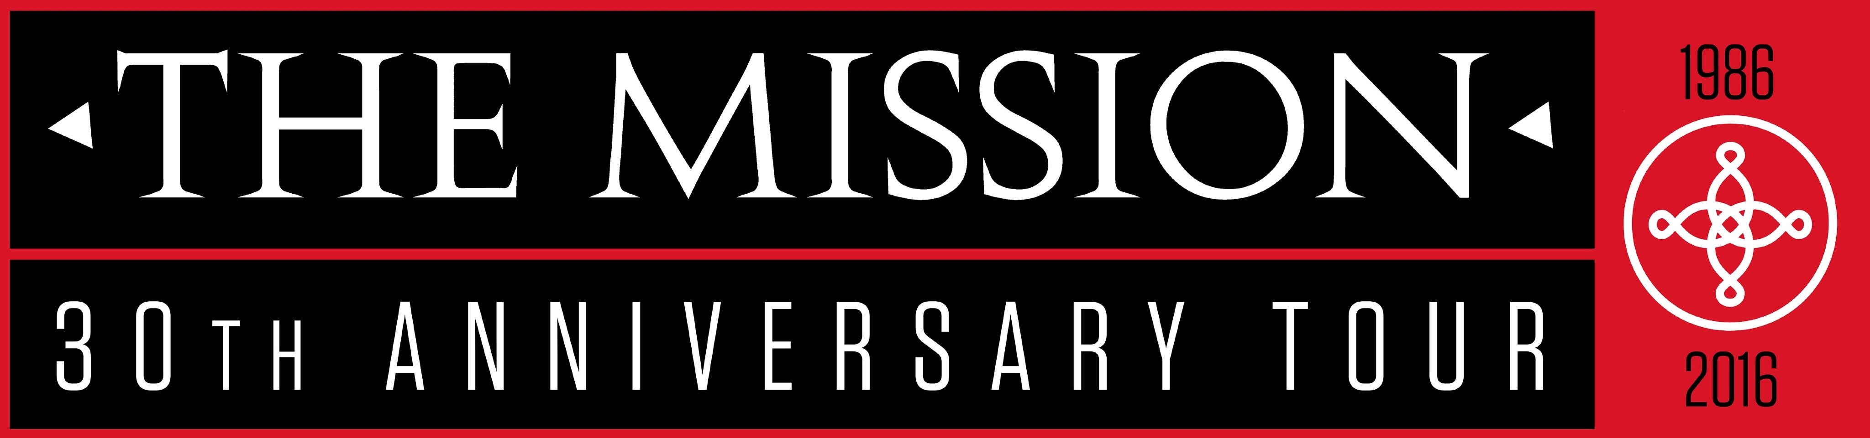

announce special guests
Pete Murphy and The 69 Eyes
for UK shows

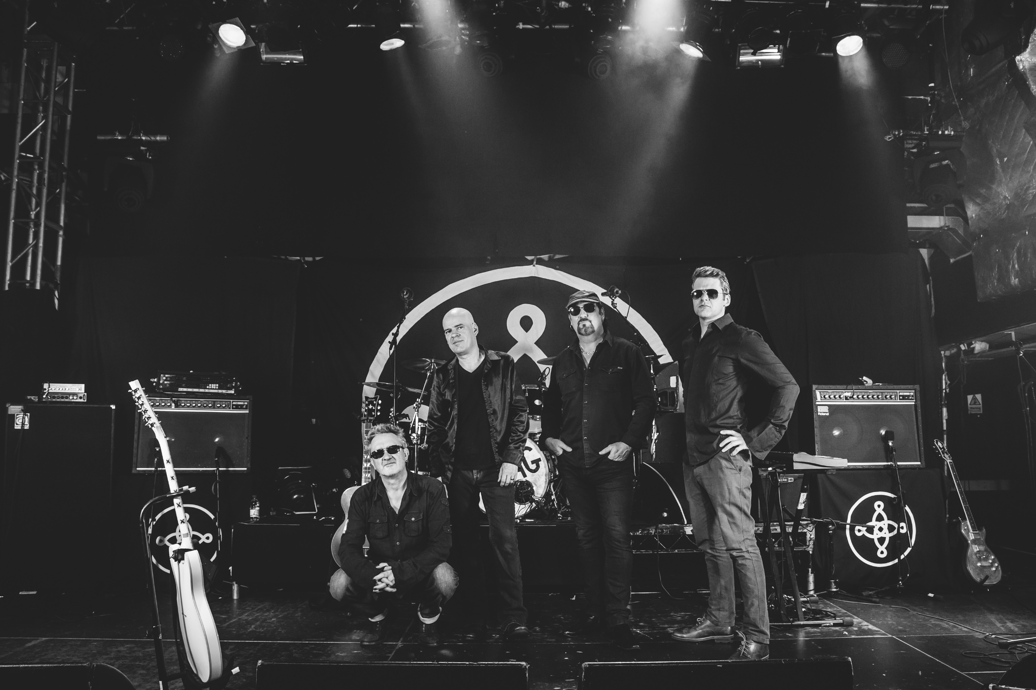

The Mission announce Pete Murphy and The 69 Eyes as their special guests for their 30th Anniversary UK shows.

To celebrate their 30th anniversary The Mission set out on their most extensive and ambitious tour since they reformed in 2011 and to coincide with the tour they will release a brand new studio album.

The 30th Anniversary European leg of the tour starts in Dublin on October 1st and includes the Whitby Goth Weekend on November 5th with Pete Murphy playing the October UK shows and The 69 Eyes the November dates.

Wayne Hussey exclaims “It’s with absolute honour and delight that I am able to tell you that Peter Murphy has agreed to play these 30th anniversary UK shows as very special guest of The Mission in October. Peter’s appearance will help make these shows the special events that we always wanted and hoped they'd be. And it’ll be great to reacquaint myself with an old friend……….

While The 69 Eyes’ singer Jyrki 69 says “I remember the first time seeing the “Wasteland” video on TV. It hit me hard, I even got the issue of Smash Hits with Wayne on the cover. “God’s Own Medicine” is still one of my favourite albums and without no doubt The 69 Eyes wouldn’t sound like we do without The Mission. Can’t wait to get back to play in the UK.”

With the original members Wayne Hussey, Craig Adams and Simon Hinkler being joined by new drummer Mike Kelly in 2011 and armed by one of the most rabid fan bases in the world The Mission have continued to excite the legions with a slew of successful shows and tours. The Mission has sold in excess of 4 million albums and singles. They have garnered headlines in the worlds music press and not always for the quality and strength of their music.
However, with a new studio album set to be released later this year and this extensive tour The Mission enter their 4th decade in the rudest of health.

The Mission UK and Ireland Tour dates
October
Sat 1st Dublin O2 Academy
Sun 2nd Belfast Limelight
Mon 3rd Glasgow O2 ABC w/ Pete Murphy
Wed 5th Manchester O2 Ritz w/ Pete Murphy
Thu 6th Nottingham Rock City w/ Pete Murphy
Fri 7th Bristol O2 Academy w/ Pete Murphy
Sat 8th London O2 Shepherds Bush Empire w/ Pete Murphy
November
Thu 3rd Leeds O2 Academy w/ The 69 Eyes
Fri 4th London O2 Forum Kentish Town w/ The 69 Eyes
Sat 5th Whitby Goth Weekend
Sun 6 Birmingham O2 Institute w/ The 69 Eyes

Tickets are now available from http://www.ticketweb.co.uk/search/?keyword=The+Mission

To pre-order the new album alongside exclusive merchandise go to http://www.pledgemusic.com/projects/the-mission

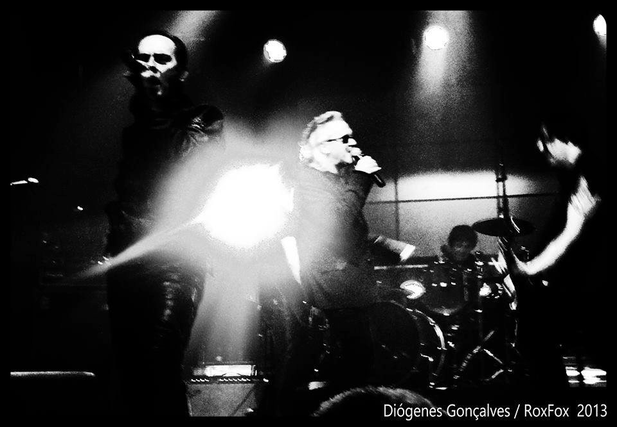

http://www.themissionuk.com/wp/

For further information please contact
Matt Reynolds
matt@savagegringo.com
Tel: +44 (0) 7889 491 504
www.savagegringo.com
Skype : savagegringo
Twitter: http://twitter.com/savagegringo
Art is the most beautiful of all lies

