Soul singer-songwriter Amahla has had an exceptional 2019, entering it as the winner of the PRS Lynsey De Paul Prize for outstanding emerging female songwriters, and ending it with over 1 million streams, two sold out headline shows and with critical acclaim for her distinctive voice and songwriting.

In February ‘19 Amahla introduced her politically-tinged contemporary soul sound with her debut EP ‘Consider This’ which was met with critical acclaim for its addressing of social issues, bold songwriting and outstanding vocal delivery, receiving impressive features and reviews from, Clash Magazine, Complex, Earmilk, The Line of Best Fit, Bandcamp and more.

“Her lyrics offer insightful, vital reflections on the present, uncertain cultural and socio-political clime, intertwined with personal narratives and memories” –London In Stereo

With a focus on live instrumentation Amahla is a commanding performer spending 2019 playing The Jazz Cafe, Roundhouse, The Royal Albert Hall, The Great Escape Festival, Cheltenham Jazz Festival, XOYO and Village Underground; in addition to selling out two of her three headline shows at The Roundhouse, St Pancras Old Church and The Lexington.

A talented songwriter in 2019 Amahla also wrote and featured on the soulful track 'In The Moment' with Drum and Bass duo Brookes Brothers which saw Amahla’s first support from Spotify on their New Music Friday UK playlist.

Amahla’s breaktaking latest single ‘Apathy’ explores the privilege of being able to ‘tune out’ of world politics. Unafraid to explore uncomfortable issues and with a voice that commands attention Amahla's talent is clearly reflected by her ambition, to be one of the best vocalists, songwriters and entertainers of her generation.

Amahla is currently being featured by o2 Music and Madison Square Gardens London as one of the UK’s best new live acts, Amahla is set for an exciting 2020.

Amahla is currently represented by Primary Talent International, Metropolis Music, Lucid Online and Clintons.

“Amahla may be one of the next big voices exported from the U.K” - Bandcamp

"She possesses the vocal ability to knock your ears clean off your head.. but instead puts all the focus and effort into the subject matter, using her singing ability as a vehicle for her stories" – Earmilk

“The Hackney riser has a deeply intelligent approach to songwriting, one that merges the personal and the political” – Clash Magazine

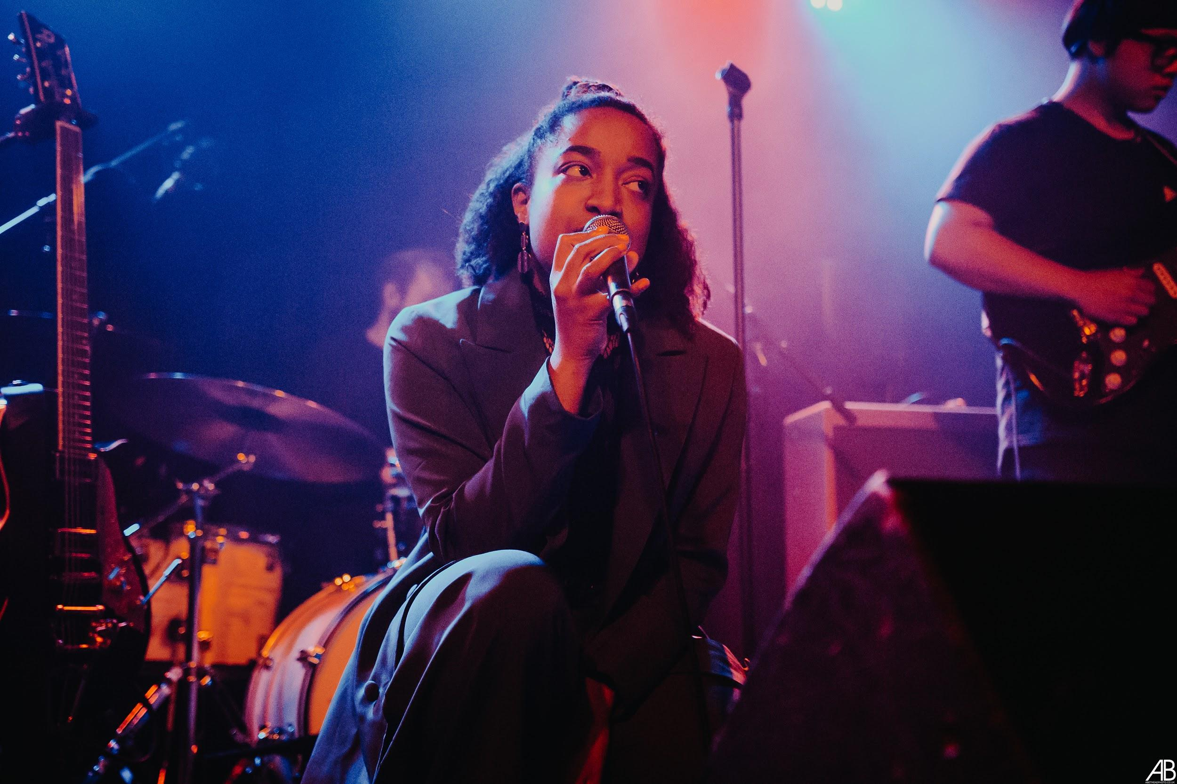
Photo by Angelah Betmead

Singer-songwriter and musician Amahla taps into an era before her time to create vintage-inspired soul music.
In 2018 Amahla was awarded the PRS Lynsey De Paul Prize for outstanding emerging female songwriters, and the MOBO Awards/Help Musicians fund for her exceptional voice.
This February Amahla released her debut EP ‘Consider This’ to critical acclaim for its vocal delivery, songwriting and addressing of social issues. She's spent 2019 playing full sets at The Jazz Cafe, Roundhouse, The Royal Albert Hall, XOYO, Village Underground The Great Escape Festival; in addition to headlining shows at The Roundhouse, St Pancras Old Church and The Lexington.
This summer she wrote and featured on a soulful track ‘In The Moment’ with Drum and Bass duo Brookes Brothers which received support on Spotify’s New Music Friday UK and currently sits just below one million streams.
This year Amahla being featured by o2 Music and MSG London as one of London’s best new live acts. Amahla is unafraid to explore uncomfortable issues and put classic songwriting at the core, aiming to make timeless music like that of idols.

“Deeply intelligent approach to songwriting” – Clash Magazine
She possesses the vocal ability to knock your ears clean off your head..but instead puts all the focus and effort into the subject matter, using her singing ability as a vehicle for her stories” –Earmilk
“Amahla may be one of the next big voices exported from the UK” – Bandcamp
“Her lyrics offer intful, vital reflections on the present, uncertain cultural and socio-political clime, intertwined with personal narratives and memories" –London In Stereo

