Under strict embargo until Wednesday 6th June 2018, 08.00AM BST

Releases her third studio album, Hunter, on 31st August 2018

Releases the album’s first single and video - "Don’t Beat The Girl Out Of My Boy” - WATCH / SHARE HERE

Announces an extensive UK and European tour for autumn / winter 2018 / 2019 with a London show at The Roundhouse on 7th February 2019

Performs her brand new live show at Heaven in London on 19th June 2018 as well as at dates in Paris and Berlin - all now sold out

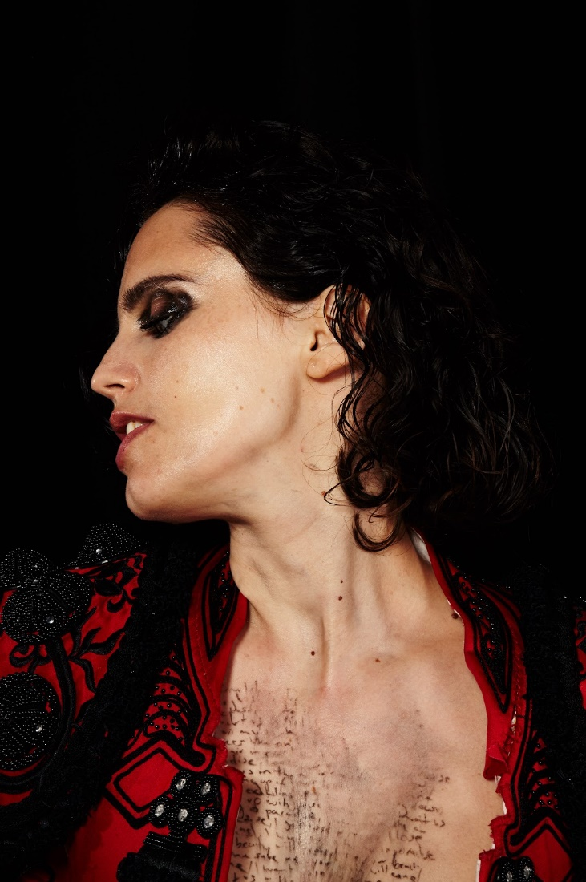
Anna Calvi photo credit Maisie Cousins

Hunter, the third long player from from the BRIT award and double Mercury Music Prize-nominated Anna Calvi, will be released on 31st August 2018 via Domino.

Produced by Nick Launay (Nick Cave, Grinderman) at Konk Studios in London with some further production in LA, the album was recorded with Anna's band - Mally Harpaz on various instruments and Alex Thomas on drums - with the addition of Adrian Utley from Portishead on keys and Martyn Casey from The Bad Seeds on bass. It has a new rawness, a primal energy into which Calvi pushes the limits of her guitar and voice beyond anything she’s recorded before.

Hunter is the embodiment of the feeling of truly letting go. For the songwriter and virtuosic guitarist, it was a catharsis, an opportunity to be more truthful than ever. The first new music since 2014’s collaborative release with David Byrne, Strange Weather EP, her self-titled debut album and the 2013 follow-up One Breath, Hunter is a visceral album exploring sexuality and breaking the laws of gender conformity. A queer and a feminist record, it is galvanising in its hunt for freedom. It was important to Calvi that it was as vulnerable as it is strong; as beautiful as it is harsh; as much about the hunted as it is about the hunter. But she’s careful not to characterise any of these traits as “masculine” or “feminine” – the whole point is that one person, of any gender, can be both. The power is in the contrast itself; in the way she oscillates between extremes, sounding freer than ever before. She wanted to express herself while being “free from the story that either gender is given, free from worrying how people would judge me on what I want to do with my body and myself. For me, that’s quite a utopian vision.”

In conjunction with today’s announcement, Calvi shares a video for the album’s first single, "Don’t Beat The Girl Out Of My Boy”. A battle cry with a rousing chorus, the song was partly written while thinking about how young children are when they’re conditioned to follow gender roles – in particular, the “heartbreaking” process through which small boys are taught not to cry or show emotions. Speaking about the track, Anna said the following: “It’s a song about the defiance of happiness. It’s about being free to identify yourself in whichever way you please, without any restraints from society.”

Directed by rising star and recent Kendrick Lamar collaborator, William Kennedy, and choreographed by Aaron Sillis (FKA Twigs), the video is available to watch and share HERE.

Anna Calvi said the following about Hunter:

“I'm hunting for something - I want experiences, I want agency, I want sexual freedom, I want intimacy, I want to feel strong, I want to feel protected and I want to find something beautiful in all the mess.

I want to go beyond gender. I don’t want to have to chose between the male and female in me. I’m fighting against feeling an outsider and trying to find a place that feels like home.
I believe that gender is a spectrum. I believe that if we were allowed to be somewhere in the middle, not pushed to the extremes of performed masculinity and femininity, we would all be more free. I want to explore how to be something other than just what I've been assigned to be. I want to explore a more subversive sexuality, which goes further than what is expected of a woman in our patriarchal heteronormative society. I want to repeat the words “girl boy, woman man", over and over, to find the limits of these words, against vastness of human experience.
I believe in the female protagonist, who isn’t simply responding to a man’s story. I go out into the world and see it as mine - I want something from it, rather than just being a passive product of it. I'm hungry for experiences. Sometimes things seem clear, and other times I feel lost. I feel strong and yet vulnerable; I wear my body and my art as an armour, but I also know that to be true to myself is to be open to being hurt.
The intent of this record is to be primal and beautiful, vulnerable and strong, to be the hunter and the hunted.”

- Anna

Hunter will be available on DIG, CD, LP and via all DSPs. It will also be available on limited edition deluxe LP 180g red vinyl with exclusive signed print, encased in a high gloss gatefold sleeve (with download code).

The physical pre-order and stream link is here. The album’s tracklist is as follows:

1. As A Man
2. Hunter
3. Don’t Beat The Girl Out Of My Boy
4. Indies Or Paradise
5. Swimming Pool
6. Alpha
7. Chain
8. Wish
9. Away
10. Eden

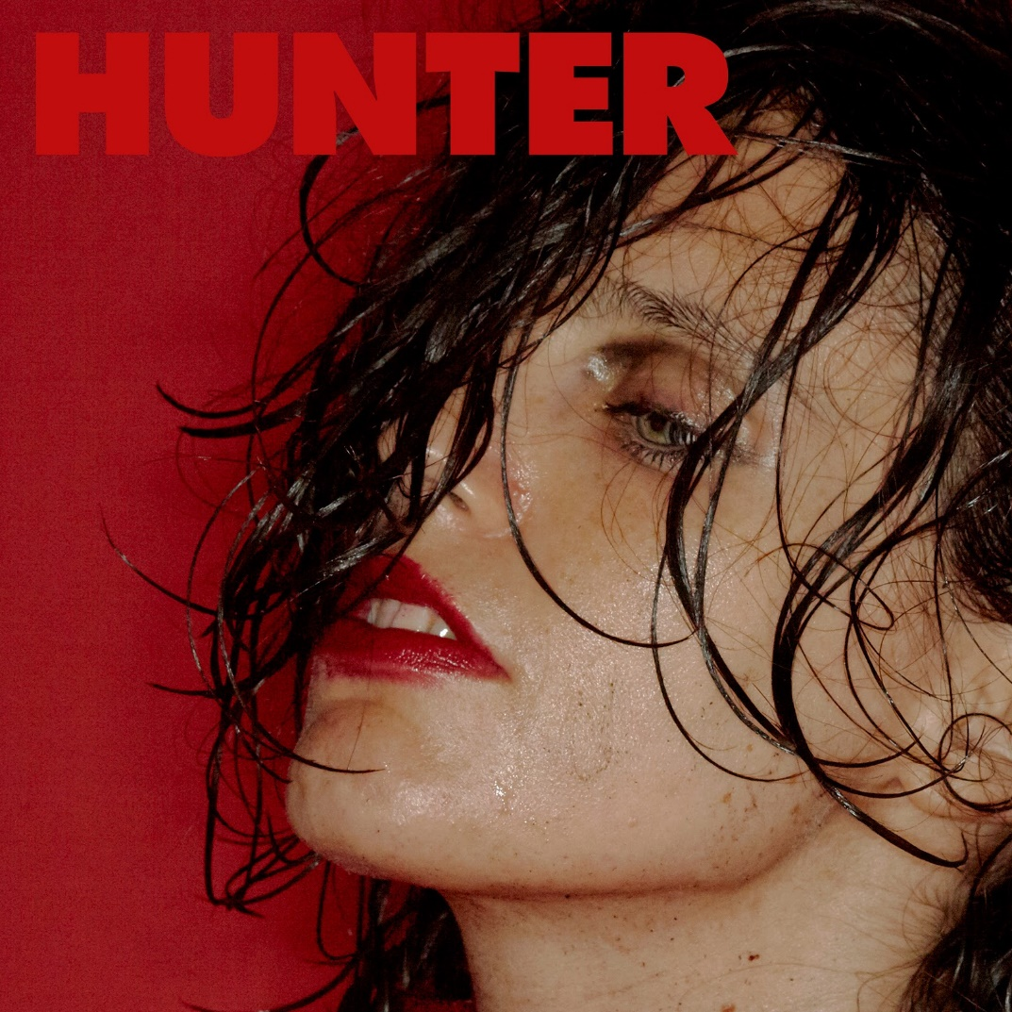
Hunter album art

Anna will perform her captivating new live show on an extensive UK and European headline tour this autumn and winter kicking off in Belfast on 27th September 2018. The tour will culminate in her biggest show to date at The Roundhouse in London on 7th February 2019. These dates will follow her first live shows in four years this month with three special performances in Berlin (Berghain), Paris (La Gaîté Lyrique) and London (Heaven) on 19th June, which are now all sold out. Full live dates are as follows and all tickets are available here:

Tue 12 June 2018 Berlin, Germany Berghain [SOLD OUT]
Fri 15 June 2018 Paris, France La Gaité Lyrique [SOLD OUT]
Tue 19 June 2018 London, UK Heaven [SOLD OUT]
Thu 27 Sep 2018 Belfast, Northern Ireland The Belfast Empire
Fri 28 Sep 2018 Dublin 8, Ireland The Tivoli Theatre
Sun 30 Sep 2018 Glasgow, Scotland St Luke’s
Mon 01 Oct 2018 Manchester, England O2 Ritz
Wed 03 Oct 2018 Newcastle, UK The Boiler Shop
Thu 04 Oct 2018 Birmingham, UK Town Hall
Fri 05 Oct 2018 Brighton, UK All Saints Church
Sat 06 Oct 2018 Bristol, UK SWX Bristol
Mon 08 Oct 2018 Lille, France Le Splendid
Tue 09 Oct 2018 La Rochelle, France La Sirene
Wed 10 Oct 2018 Nantes, France Stereolux
Sat 13 Oct 2018 Valencia, Spain La Rambleta
Sun 14 Oct 2018 Barcelona, Spain Cruïlla de Tardor @ Razzmatazz 2
Tue 16 Oct 2018 Madrid, Spain Chango
Wed 17 Oct 2018 Santiago, Spain Sala Capitol
Fri 19 Oct 2018 Porto, Portugal Hard Club
Sat 20 Oct 2018 Lisbon, Portugal Capitolio
Mon 22 Oct 2018 Lyon, France Le Radiant
Tue 23 Oct 2018 Strasbourg, France La Laiterie
Wed 24 Oct 2018 Utrecht, Netherlands Tivoli Vredenburg, De Helling
Thu 25 Oct 2018 Brussels, Belgium Botanique
Sat 27 Oct 2018 Odense, Denmark Posten
Mon 29 Oct 2018 Oslo, Norway Parkteatret
Tue 30 Oct 2018 Stockholm, Sweden Nalen
Thu 01 Nov 2018 Helsinki, Finland Tavastia Club
Sat 03 Nov 2018 Lund, Sweden Mejeriet
Sun 04 Nov 2018 Copenhagen, Denmark Vega
Mon 05 Nov 2018 Aarhus, Denmark Voxhall
Wed 07 Nov 2018 Warsaw, Poland Niebo
Thu 08 Nov 2018 Prague, Czech Republic Lucerna
Fri 09 Nov 2018 Leipzig, Germany Conne Island
Sat 10 Nov 2018 Weissenhäuser Strand, Germany Rolling Stone Weekender
Mon 12 Nov 2018 Bratislava, Slovakia Nova Cvernovka
Tue 13 Nov 2018 Budapest, Hungary A38 Ship
Thu 15 Nov 2018 Vienna, Austria Simm City
Fri 16 Nov 2018 Rust, Germany Rolling Stone Park
Sat 17 Nov 2018 Fribourg, Switzerland Le Nouveau Monde
Sun 18 Nov 2018 Zurich, Switzerland Plaza Club Zurich
Tue 20 Nov 2018 Ljubljana, Slovenia Kino Siska
Wed 16 Jan 2019 Munich, Germany Freiheiz
Fri 18 Jan 2019 Berlin, Germany Astra Kulturhaus
Sat 19 Jan 2019 Hamburg, Germany Kampnagel
Tue 22 Jan 2019 Cologne, Germany Gloria Theatre
Wed 23 Jan 2019 Amsterdam, Netherlands Melkweg
Fri 25 Jan 2019 Nancy, France L'Autre Canal
Sat 26 Jan 2019 Nimes, France Paloma
Sun 27 Jan 2019 Toulouse, France Le Bikini
Tue 29 Jan 2019 Bordeaux, France Le Rocher de Palmer
Thu 31 Jan 2019 Reims, France La Cartonnerie
Thu 07 Feb 2019 London, UK The Roundhouse

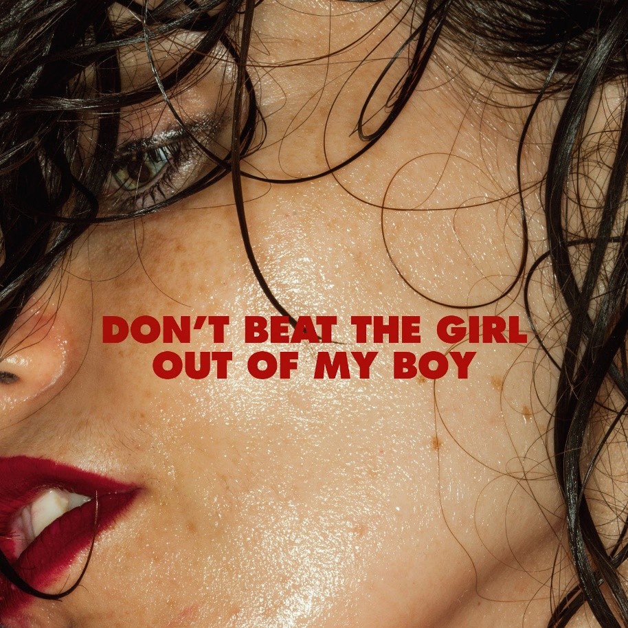
Don’t Beat The Girl Out Of My Boy single art

For UK PR enquiries please contact:
Jodie Banaszkiewicz | Stay Golden PR | jodie@staygoldenpr.com

