CHARLOTTE ADIGÉRY
Reveals Video for New Single ‘High Lights’
“Zandoli” LP out 8 February via DEEWEE

<screen grab>

Charlotte Adigéry today unveils the video for her new single ‘High Lights’, taken from her forthcoming EP Zandoli, due for release on 8 February via DEEWEE.

Speaking about ‘High Lights’, Adigéry says: “’High Lights’ and the whole world around it was a big source of inspiration for the EP. It was the first song written for the EP and it inspired me to explore my identity as a Caribbean black woman raised in Belgium. It started off as a celebration of the feminine black culture and then resulted in me writing more in Creole and translating my heritage through music."

<screen grab>

Director Joaquim Bayle adds: “‘High Lights’ has a very specific theme based on a very personal subject the artist wanted to talk about. From the start I was so curious and hooked by the song and this world which from the exterior seems so much "coded.” We wanted to amplify the provocative and nonchalance of the song by adding some fantasy bits to the mix.”

With her new EP Zandoli, Belgian-Caribbean artist Charlotte Adigéry proves herself to be a consummate storyteller. Sometimes patently silly, sometimes deeply introspective, Adigéry’s ever-wandering mind spins tales that are absurd and poignant and ridiculously fun. Having been taught the ropes by her Martinique-born mother –namely rhythm’s relationship to musicality and the importance of a sense of humour– Adigéry is a persuasive young artist who can sing about lizards one moment and latex the next.

A descendent of a Nigerian Yoruba tribe that worked its way out of slavery on the faraway island of Martinique, Adigéry likes to draw inspiration from her Caribbean ancestors’ musical traditions. Opening track ‘Paténipat’ features a chanted chorus of “zandoli pa té ni pat” –a Creole mnemonic that means “the gecko didn’t have any legs”– which perfectly enunciates the rhythms of the GWO KA dances that would have swayed the islanders of Martinique a century ago. A zandoli, by the way, is a lizard normally found climbing the walls of Caribbean homes.

Lead single ‘High Lights’ is an ode to the transformative power of weaves. (“I know I shouldn’t do it but / I love synthetic wigs a lot.”) Adigéry explains: “Hair is such a powerful organ, and it’s a very powerful way to express yourself. Black women have been playing with their appearance and hair for decades. I want to honour that culture.”

There’s great sex appeal on Zandoli too – though frequently of the hilarious variety. On ‘Cursed and Cussed’ Adigéry sets the scene for the XXX-remake of Brokeback Mountain. (“Squeaking leather, skin on skin / Latex singing songs of sin”) Meanwhile ‘B B C’ sees her contemplate sex tourism for middle aged women. (“It’s not wrong if it’s consensual / Never too old to feel real sensual.”)

EP closer ‘Okashi’ sweetly advertises a moreish drug that returns childlike sensory perception. (“A single drop will raise your earliest memories / A single drop could be the quickest remedy”) “But,” Adigéry warns, “nothing can truly bring you back to those experiences. It’s still a drug like any other…”

While never addressing love directly, Zandoli is a product of pure love and friendship. In the studio Adigéry is joined by collaborator Bolis Pupul, a descendant of the first and only wave of Chinese immigration to Martinique. After matching on Tinder the pair began to explore their shared histories, resulting in heart-to-heart confessions that seep through the songs of Zandoli. “Since working on our first EP, Bolis and I have become best friends,” Adigéry says. “And this record is the product of our love.”

Produced by DEEWEE label bosses David and Stephen Dewaele (aka Soulwax, aka 2Many DJs), Zandoli EP is due for release on 8 February.

UK live dates will be announced shortly.

Pre-Order “Zandoli” EP
http://smarturl.it/Zandoli
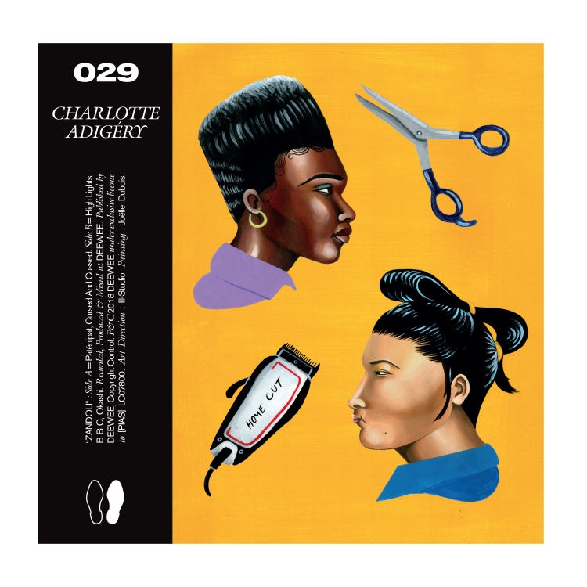

Track List

1. Paténipat
2. Cursed and Cussed
3. High Lights
4. B B C
5. Okashi

Connect

https://twitter.com/adigerwww
https://www.facebook.com/charlotteadigery/
https://www.instagram.com/adigerwww/

