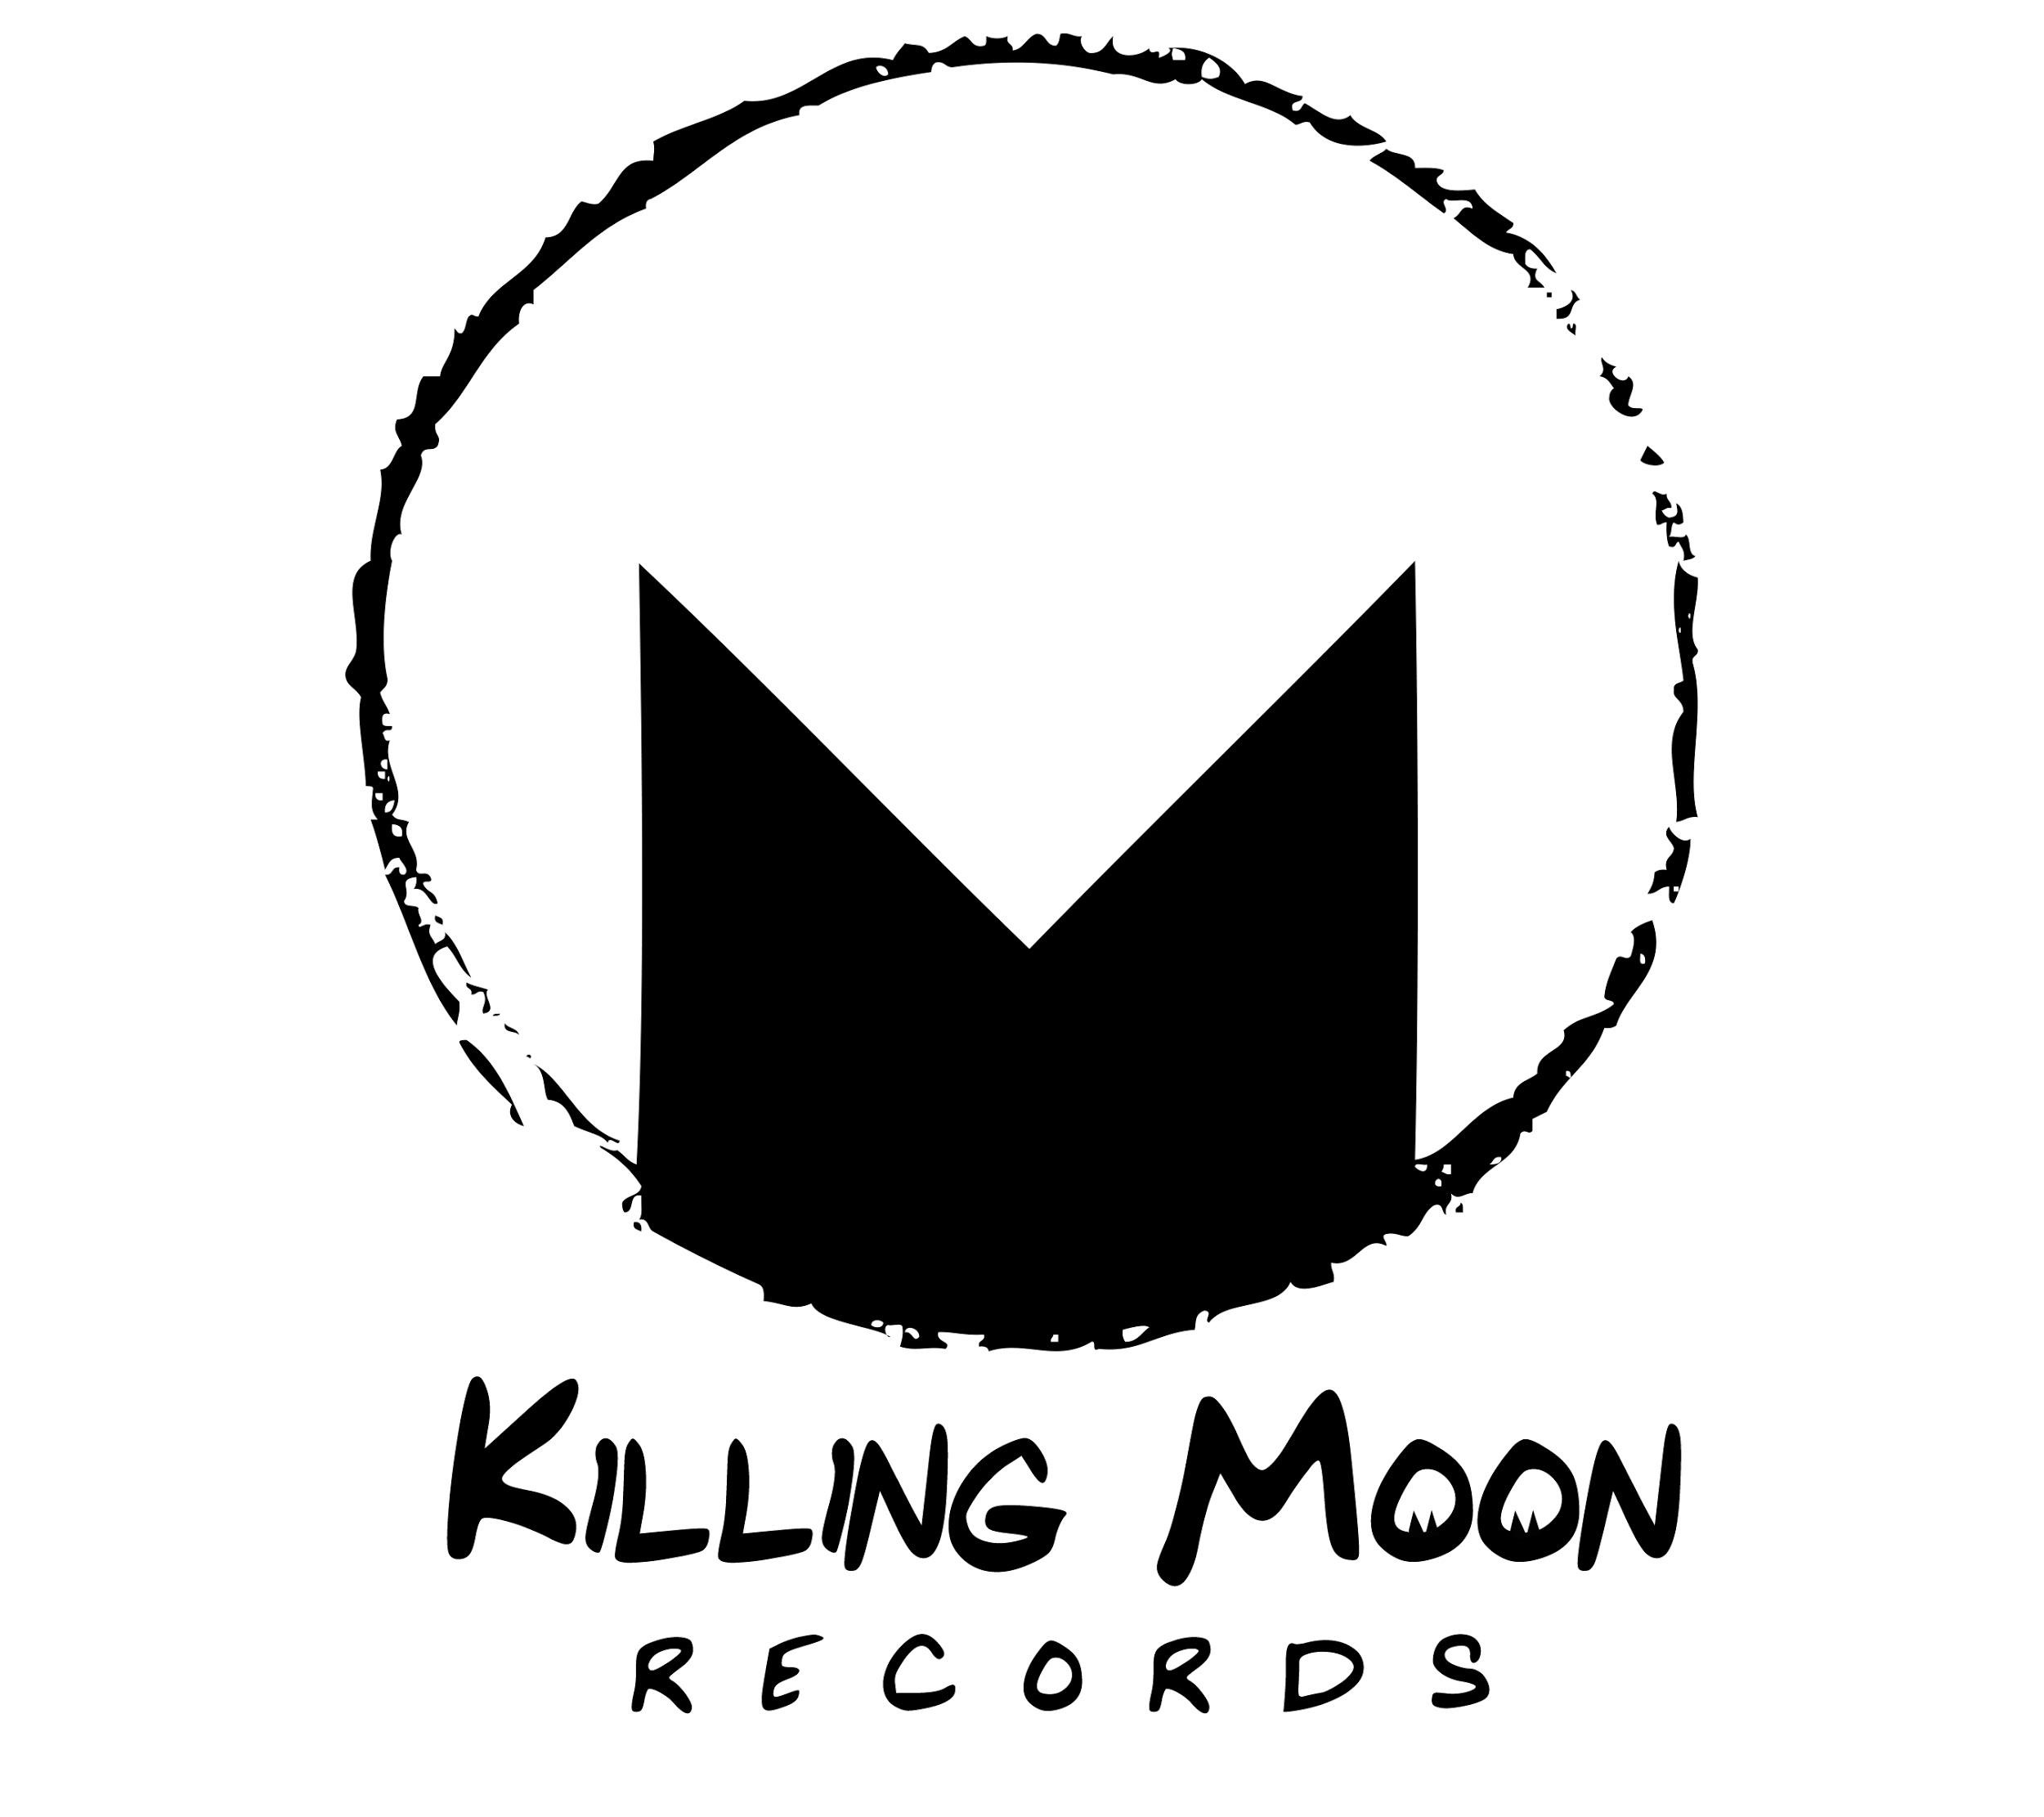

GINGER SNAPS ANNOUNCES NEW SINGLE
‘NUMBER CRUNCHING’ + UK TOUR DATES

LISTEN:
https://soundcloud.com/killingmoon/gingersnaps-number-crunching/s-xD7na

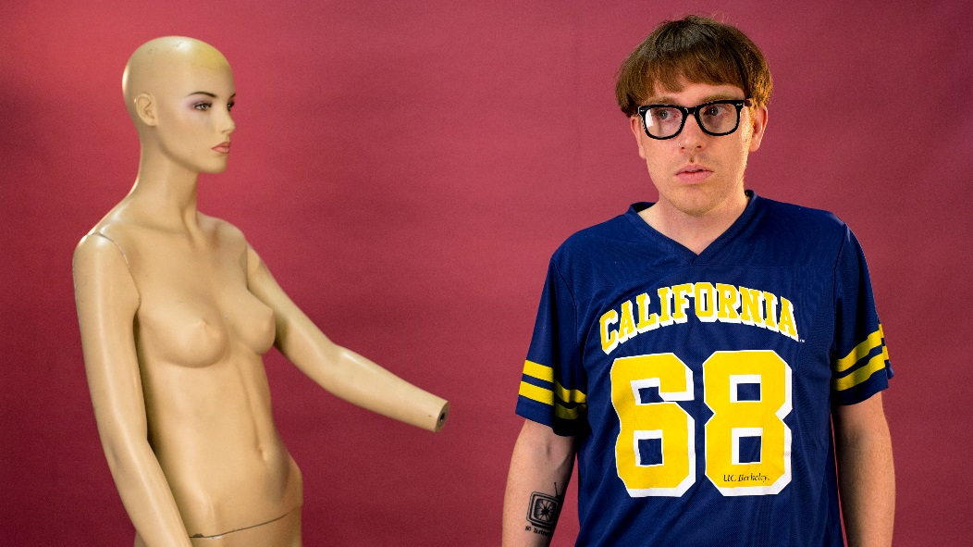

“Baggier than a vintage shop’s sale rail and laced in all manner of swirling psych, Ginger Snaps’ breakbeat pop is as flexible as they come."
DIY

“Ginger Snaps dwells in slacker climes, matching fuzzed up riffs against boom-bap hip-hop beats. Re-calls everyone from Beck to De La Soul, but really it could only come from the mind of a certain Northampton dweller”
CLASH

"If there's a band that's needed right now its Ginger Snaps; melding oldskool hip hop breaks with modern day pop sensibilities”
BBC Introducing

“I just love his sound. Great beats and fun lyrics. Turn it up. Proper feel good vibes on this.”
BBC Radio 1’s Abbie McCarthy

Following the release of the hugely successful ‘Phat Kids’, Ginger Snaps is back with with a raucous new single ‘Number Crunching’, set for release on the 17th March 2017.

Ginger Snaps are the multi-instrumentalist, writing and production duo Jay Brook and Lee Irons from Northampton.

Whilst also being a main writing team for the Radio X play-listed OhBoy!, Jay & Lee have spent time in their Northampton Lab cooking up a brand new sound. Continuing their flair for off kilter indie pop, Ginger Snaps’ latest release ‘Number Crunching’ is a catchy, retro inspired, pop track with singable hooks, jangly 60’s style guitar, and a groove-laden rhythm section, providing the perfect setting for Jay’s gritty vocals.

Forming Ginger Snaps in April 2015, Jay & Lee set out on a new musical adventure, a recipe they'd been eager to debut for years through various musical endeavors but finally felt ready to showcase. First out the door came debut 'Paranoid' in May, a raucous, funk laden record, drenched in baggy instrumentation and groove effects, made pristine through Jay's self-aware commentary and raspy delivery.

CLASH were quick to premiere the track and Radio X were made fans – adding it straight onto the Evening List. Radio 1’s Huw Stephens added it to his BBC Introducing Playlist, 6Music’s Tom Robinson put it on his BBC Intro Mixtape and BBC Northampton brought Jay & Lee in to talk about their sudden ascension.
‘Phat Kids’ became the bold second single when released in July - where the duo received further high praise from DIY & Radio 1's Annie Mac - at which point she made Ginger Snaps one of her esteemed August #NewNames.

Amazing Radio were next to highlight the track by adding it to their ‘A-List’ – climbing into the Top 10 of the Amazing Chart. The track has just been re-released stateside courtesy of ECG Records (Gaslight Anthem, Twin Atlantic).

A Ginger Snaps live show debuted when Radio 1's Abbie McCarthy asked the band to play her monthly Good Karma Club in Islington in September, showcasing a refreshingly different live set up involving parts of a gospel choir and a veteran scratch DJ.

Number Crunching’ was premiered by Abbie McCarthy on BBC Radio 1 on the 13th March, and since then, the track has picked up support from Virgin Radio’s Edith Bowman, and recieved it’s first online premiere from Dork Magazine.“Number Crunching” is set for release on 17th March via Killing Moon Records, and Ginger Snaps will be hitting the road throughout March on the following dates.

21st March - London, The Social (Radio X’s Jack Saunders pres. Hopscotch)
25th March - Northampton, Lamplighter
27th March - Brighton, Prince Albert
31st March - Manchester Fallow Cafe

RADIO: russell@viaductpromotions.co.uk
ONLINE: tom@killing-moon.com
MGMT: cullenkieran@gmail.com

CONNECT WITH GINGER SNAPS
FACEBOOK SOUNDCLOUD SPOTIFY

