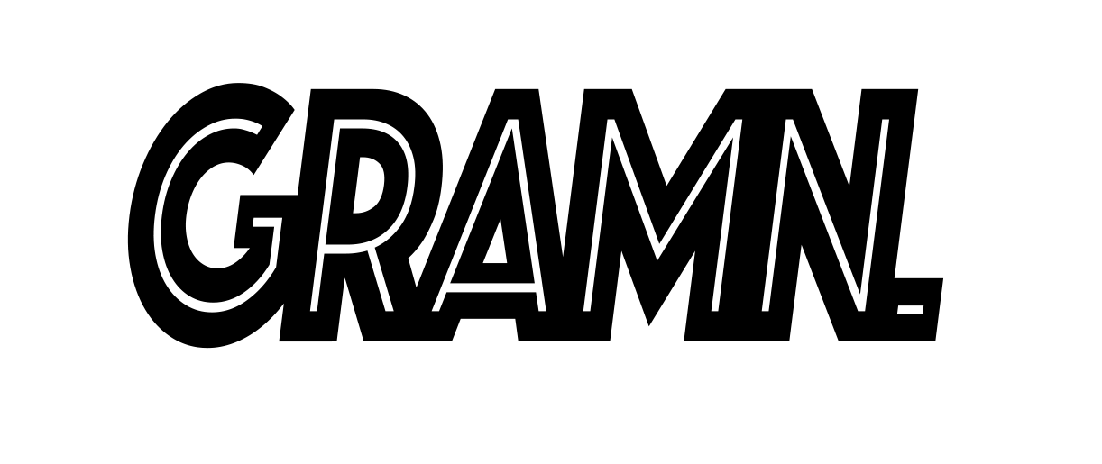

Awks emerges into the spotlight after years of working with London’s freshest talent including Kemi Ade and Jerome Thomas to front her own project, GRAMN. GRAMN. is the irreverent voice of a young woman who tackles the trauma of her youth by creating raggo but honest music. Imagine a contemporary British Missy Elliot who spent time in detention singing with Jackie Wilson, left and made dark Trap and R&B tunes with Lapalux

Production comes from James Lowe (Equals) and instrumentation from Johnny Tomlinson (Bonobo live).

