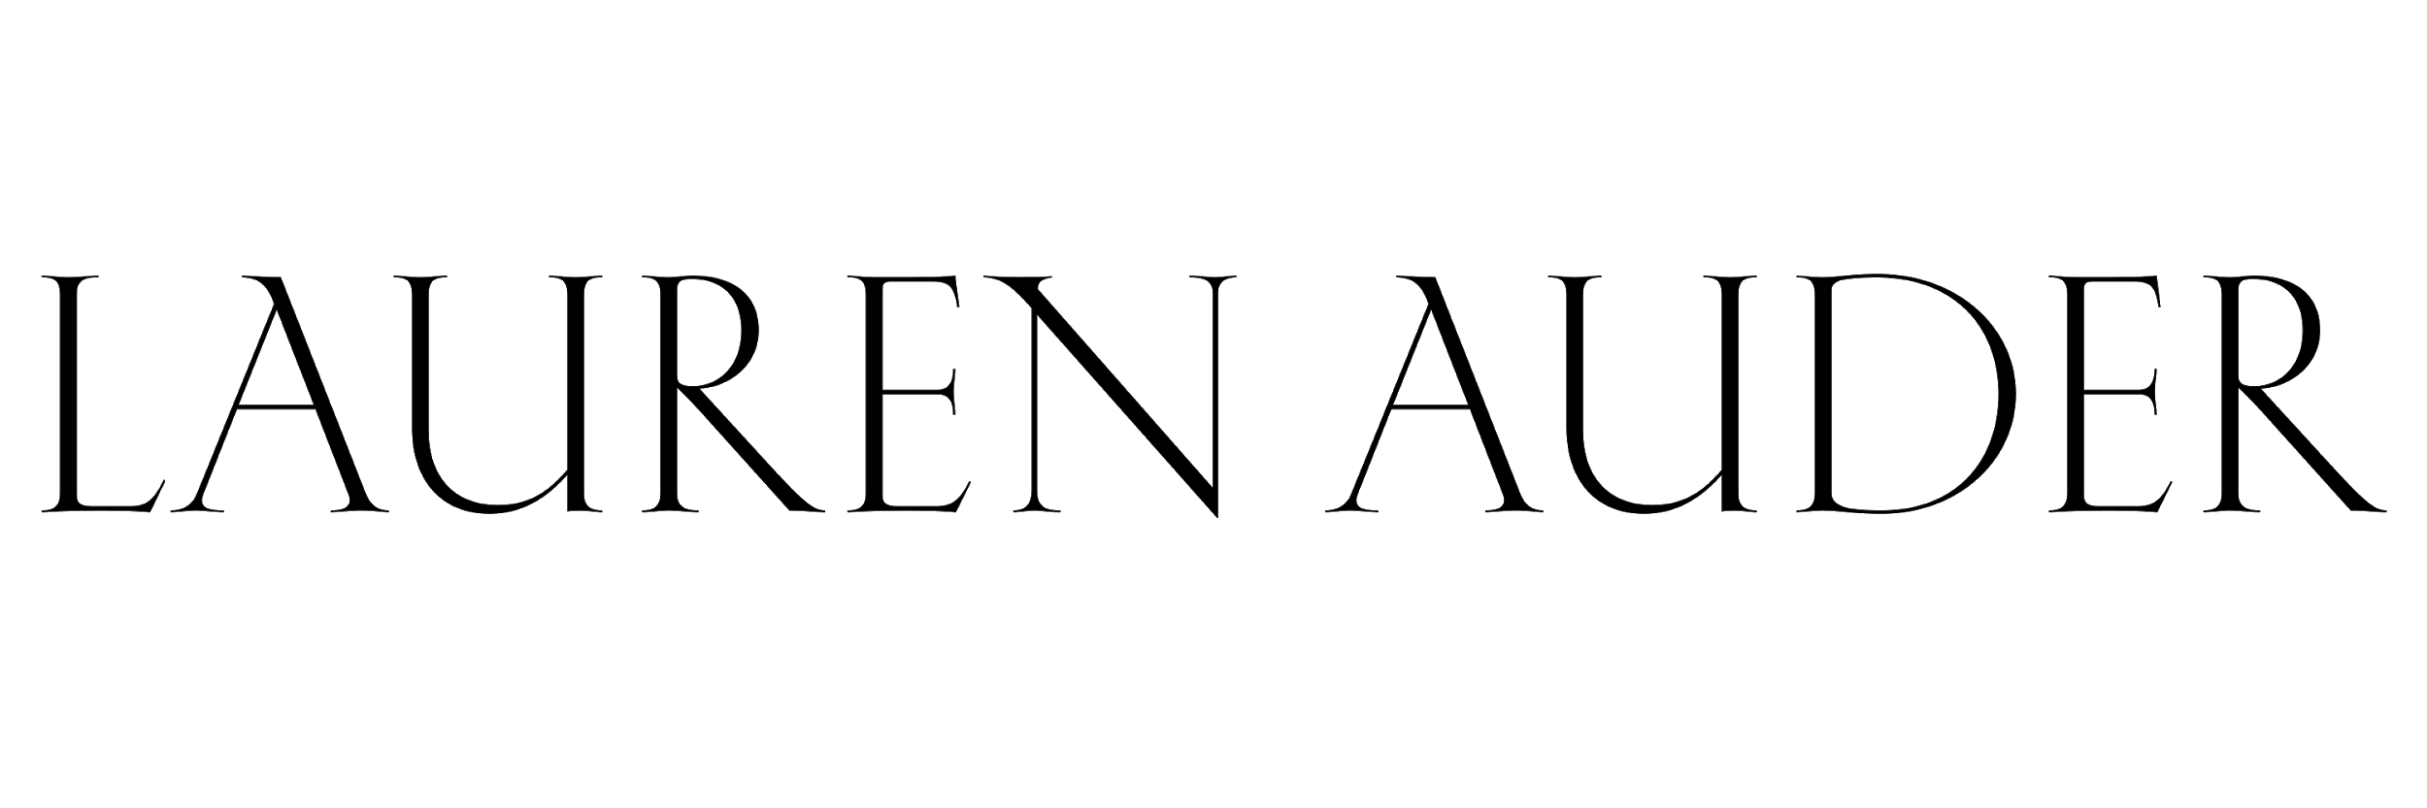
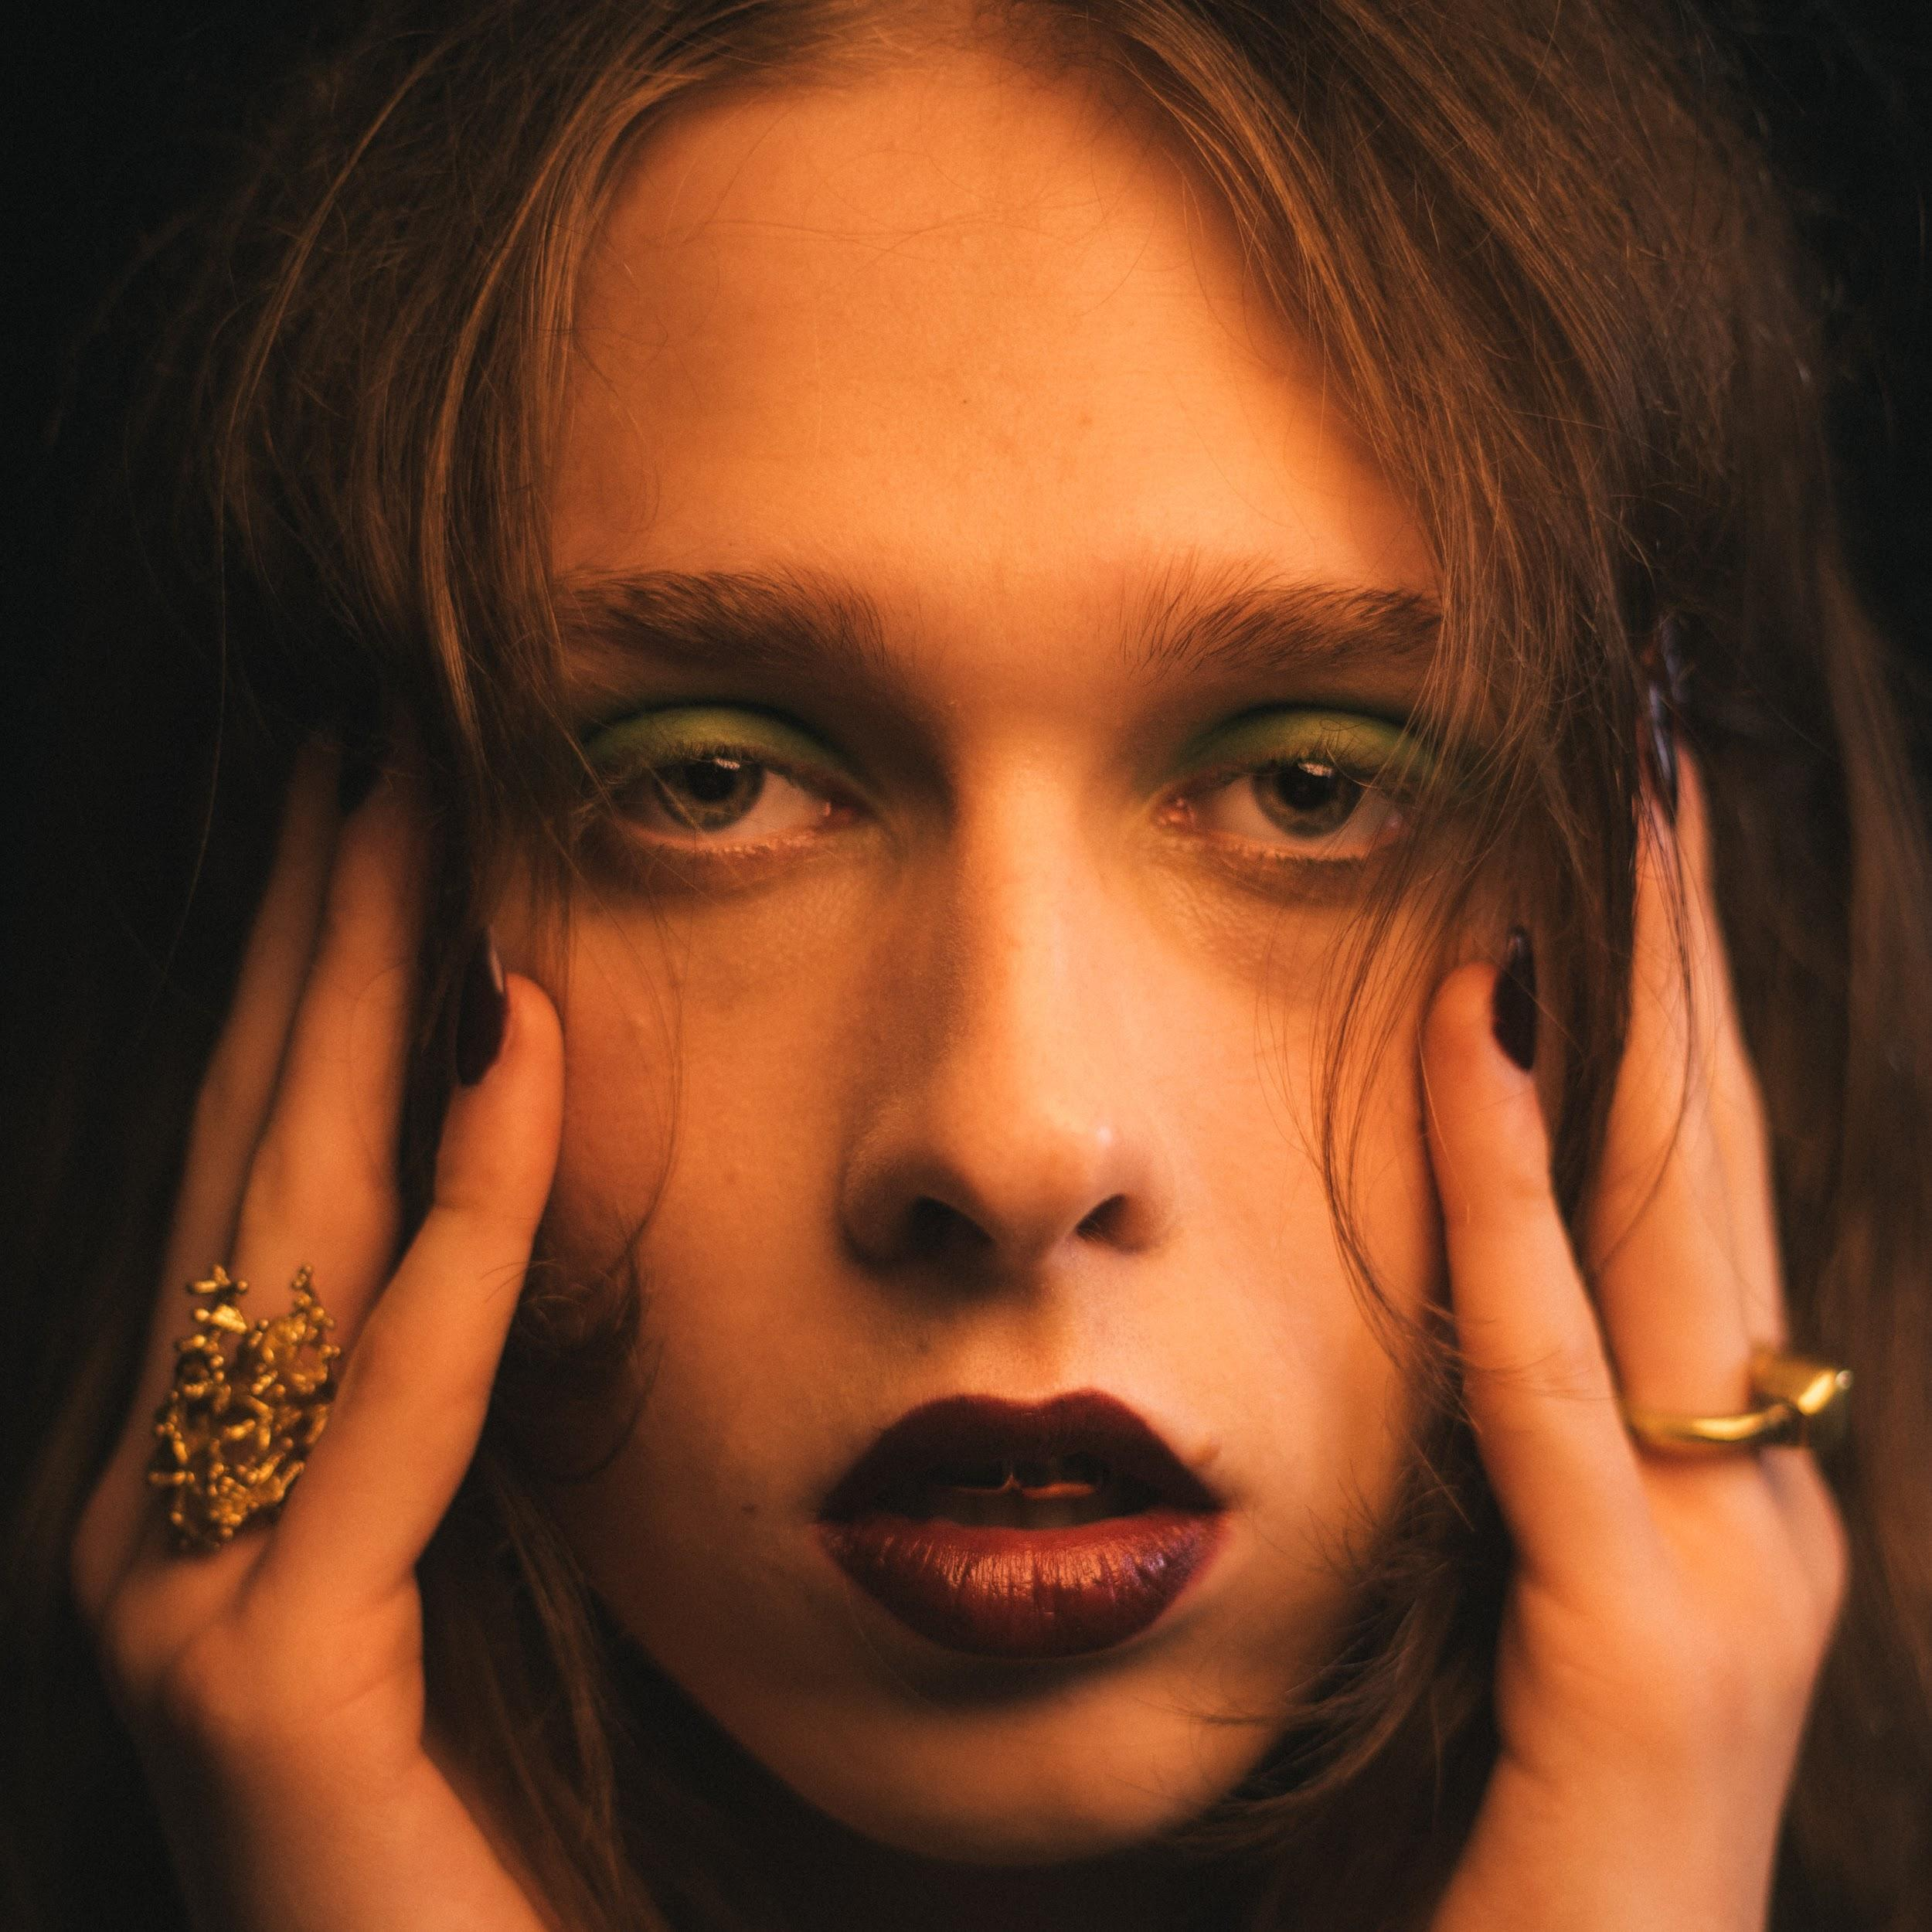

London-based Lauren Auder is a 21 year old singer who’s baroquely orchestrated pop songs implore a Classical lens to contemporary themes of millennial discontent via Christian allegory and pagan symbolism. Growing up in Albi, a Southwestern French town built around the Gothic Cathedral of Saint Cecilia, Lauren found community online, becoming involved with a vibrant underground community of rappers and noise musicians that included a teenage slowthai, Oklou and Lord Pusswhip. Honing an early musical craft, Lauren began lending experimental beats and spectral vocals to songs by artists such as Jeshi and slowthai. The resultant interpretations of hip-hop, post-rock and noise gave rise to the expansive sonic palette of Lauren’s debut EP Who Carry’s You, a deeply intimate, classically endowed five track suite that owes equally to Scott Walker, Godspeed You! Black Emperor and DJ Shadow.
Following this release, Lauren found inspiration in the poems of William Blake, taking to the Jura mountains with bandmate and collaborator DVIANCE to imagine its follow up: two caves in. With a similar fluid regard to genre as seen Who Carry’s You and early soundcloud offerings, two caves in revels with fevered grace in a trajectory through innocence and coming of age. Christian allegory intermingles with topics of millennial despondency, interpersonal relationships and identity. Fusing the classical with the post-rock and popular song structure, Auder paints vivid musical portraits situated in a novel medium between Lorde and the Divine Comedy.
Lauren has toured internationally with Christine & The Queens and Amen Dunes. Additionally, Lauren has modeled for Gucci and was the face for Hedi Slimane’s debut collection for Celine in 2018.

