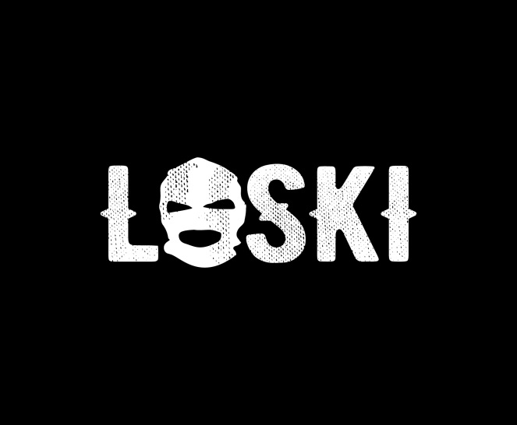

Every area has a top boy – an influence that the local kids look toward as an inspiration, a source of power, a king. In the south London district of Kennington, that star is an eighteen-year-old MC called Loski.

Released off the break out singles “Money & Beef” and “Cool Kid” – tracks that quickly cemented Loski as the one to watch in London’s drill scene, each racking up a cool two and a half million views – ‘Call Me Loose’ is set to put Kennington and, by proxy, Loski on the map. But for the uninitiated, let’s lay out his back-story.

Standing apart from some of the United Kingdom’s less-lived musicians, Loski didn’t grow up with musical aspirations. Instead, he initially sought out a career as a professional football player. Then came a roadblock: an injury that poured water on the fire of Loski’s future prospects, leading him to become dropped. “When you’re younger that stuff gets to you. I thought ‘nah, this isn’t for me,’” he says today.

With football out the way, Loski started to roll around his neighbourhood. Like most kids his age, he became caught up in the trappings of his area. Drill began to pop off around the same time and Loski and his pals found inspiration in the young Chicago artists who were making a name for themselves. “50 Cent is hard but we don’t relate to him as much. Chicago drill artists were young and in the streets like us, so we related to them more. ‘Oh, they’re only 15/16 – they’re just like us,’” he remembers.

“Everyone used to say ‘yeah you’re hard, rap rap,’” Loski says. And so, that’s exactly what he did. In 2016 – at 16 years old – he released “Hazards”, the track that first illuminated his name among the UK music scene. Still, music was for fun, to make a noise, and Loski didn’t anticipate the reaction it received. “[I started to make music] to let everyone know ‘this is my area’. I wanted to show everyone that ‘this is us’. But everyone liked it and it brought more attention than I expected.”

These initial sparks quickly solidified into a deeper meaning for Loski, who soon came to see music as his vocation – as a way to spark positive change by virtue of laying the truths of his experience down on wax. “There’s never been someone from my area that’s been known. No one has come out of Kennington to be something good, something great,” he explains. And it seems to be working. These days, Loski’s social networks are lit-up with messages that keep him rolling with music. “ I’ll look in my DMs on Instagram and people will say sick things like ‘You mean everything, don’t stop’ or ‘I don’t know what you would do if you didn’t do music,’ he laughs. “That’s what makes me want to carry on.”

Those who first came to Loski through his previous releases will find something to love in his debut mixtape ‘Call Me Loose’, which is centred in the drill sound he first came to be celebrated for. But there’s also a progression. For a start, the mixtape is cinematic. “Drill” samples a political speech about gang crime, “Broad Day” has the kind of low-key and emotive piano strokes you might hear on a film soundtrack, and the record is bookended by an intro and outro. And then there’s the shift in tone, with the upbeat production of previous single “Cool Kid” leading into “Forrest Gump” – a track that seems built for a sun-soaked summer time shubz rather than moonlit rainy streets.

“No one’s aunty wants to listen to drill,” Loski jokes of his slight shift in direction toward the end of the tape. That said, kids are devouring drill and its clear Loski is one of the genre’s main players. By expanding his palette and bringing in hints of afro-trap, Loski is expanding far beyond any of his peers. He is the creator of a completely unique new sound Afro-drill, which is continuously evolving and rising to power under his leadership. Rich in terminology that can only come from an MC who has lived a life on road and emerged onto the other side, ‘Call Me Loose’ presents an honest artist who is looking forward and unafraid to level up. In fact, he’s already set his sight far beyond his area. The next stop? “I want to have a label one day.” The Kennington king has spoken.

