MEGGIE BROWN

Shares debut single ‘Coming Back Again’:

https://soundcloud.com/meggiebrownmusic/coming-back-again-edit-unmastered/s-BMnIu

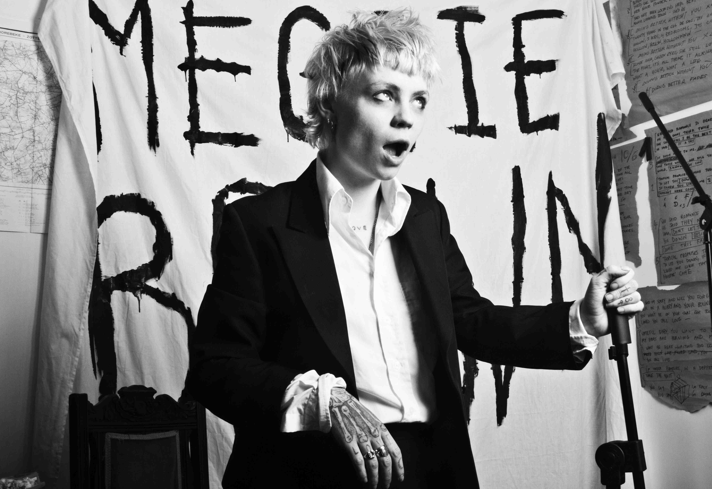

Meggie Brown has announced details of the release of her debut single, ‘Coming Back Again’, available on streaming platforms now and via SoundCloud here.

Produced by Franz Ferdinand’s Alex Kapranos at Edwyn Collins’ studio in Helmsdale, in the Scottish Highlands, the song is darkly upbeat, whilst speaking of themes of paranoia and the surreal headspace of others’ addictions.

One of the capital’s most exciting newcomers, Meggie Brown’s first recording is a culmination of rehearsals in a windowless room in a North London warehouse, doubling as a shared bedroom, with pedals cluttering the floor and lyrics on brown paper covering the walls - a seemingly fitting setting considering the song’s subject matter.

Meggie Brown recently introduced herself via sarcastic and slightly unhinged live performances across the capital – the result of the unorthodox relationship between Meggie and her strange family of a band.

They rehearsed every day in a lived-in and dimly lit attic studio, where the speakers picked up radio frequencies and the dog sensed a haunted presence in the corner. It was at this mansion that they played their first show, followed by a party that hosted 400 people under red lighting, all dressed in black and white – which subsequently resulted in their eviction.

See Meggie Brown and band on the following dates:

FEB

23rd - Corn Exchange, Cambridge (w/ Franz Ferdinand)
24th - O2 Academy Brixton (w/ Franz Ferdinand)
25th - The Dome, Brighton (w/ Franz Ferdinand)

FACEBOOK // INSTAGRAM

For further information contact:
Matthew Fogg @ Carry On Press
matthew@carryonpress.co.uk

