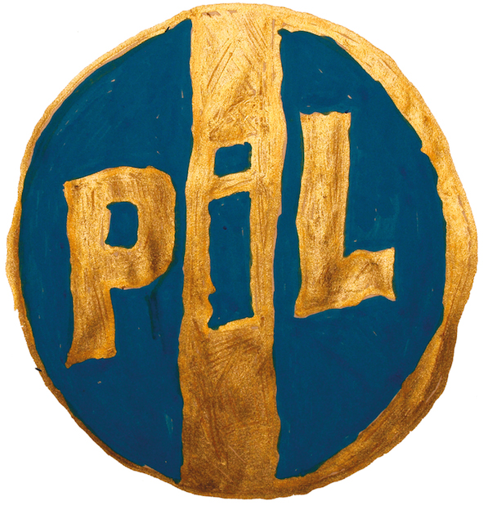

PUBLIC IMAGE LTD (PiL) ANNOUNCE SUMMER 2016 UK / EUROPEAN TOUR, STARTING FRIDAY MAY 6th AT VALENCIA, NOIZE CLUB, SPAIN
- INCLUDING RETURN TO LONDON, INDIGO AT O2, SATURDAY JUNE 4th

Tickets:
Pre-sale: Friday, January 15th
General sale: Monday, January 18th
See www.pilofficial.com for ticket links and info…

Following on from highly successful 2015 dates in UK, Europe and North America John Rotten Lydon’s Public Image Ltd (PiL) are pleased to announce a further UK/Europe summer tour kicking off in Valencia, Spain on Friday, May 6th (see below for all dates). Several of the 2015 dates were sold-out and regarded by many as the best performances the band have ever played.

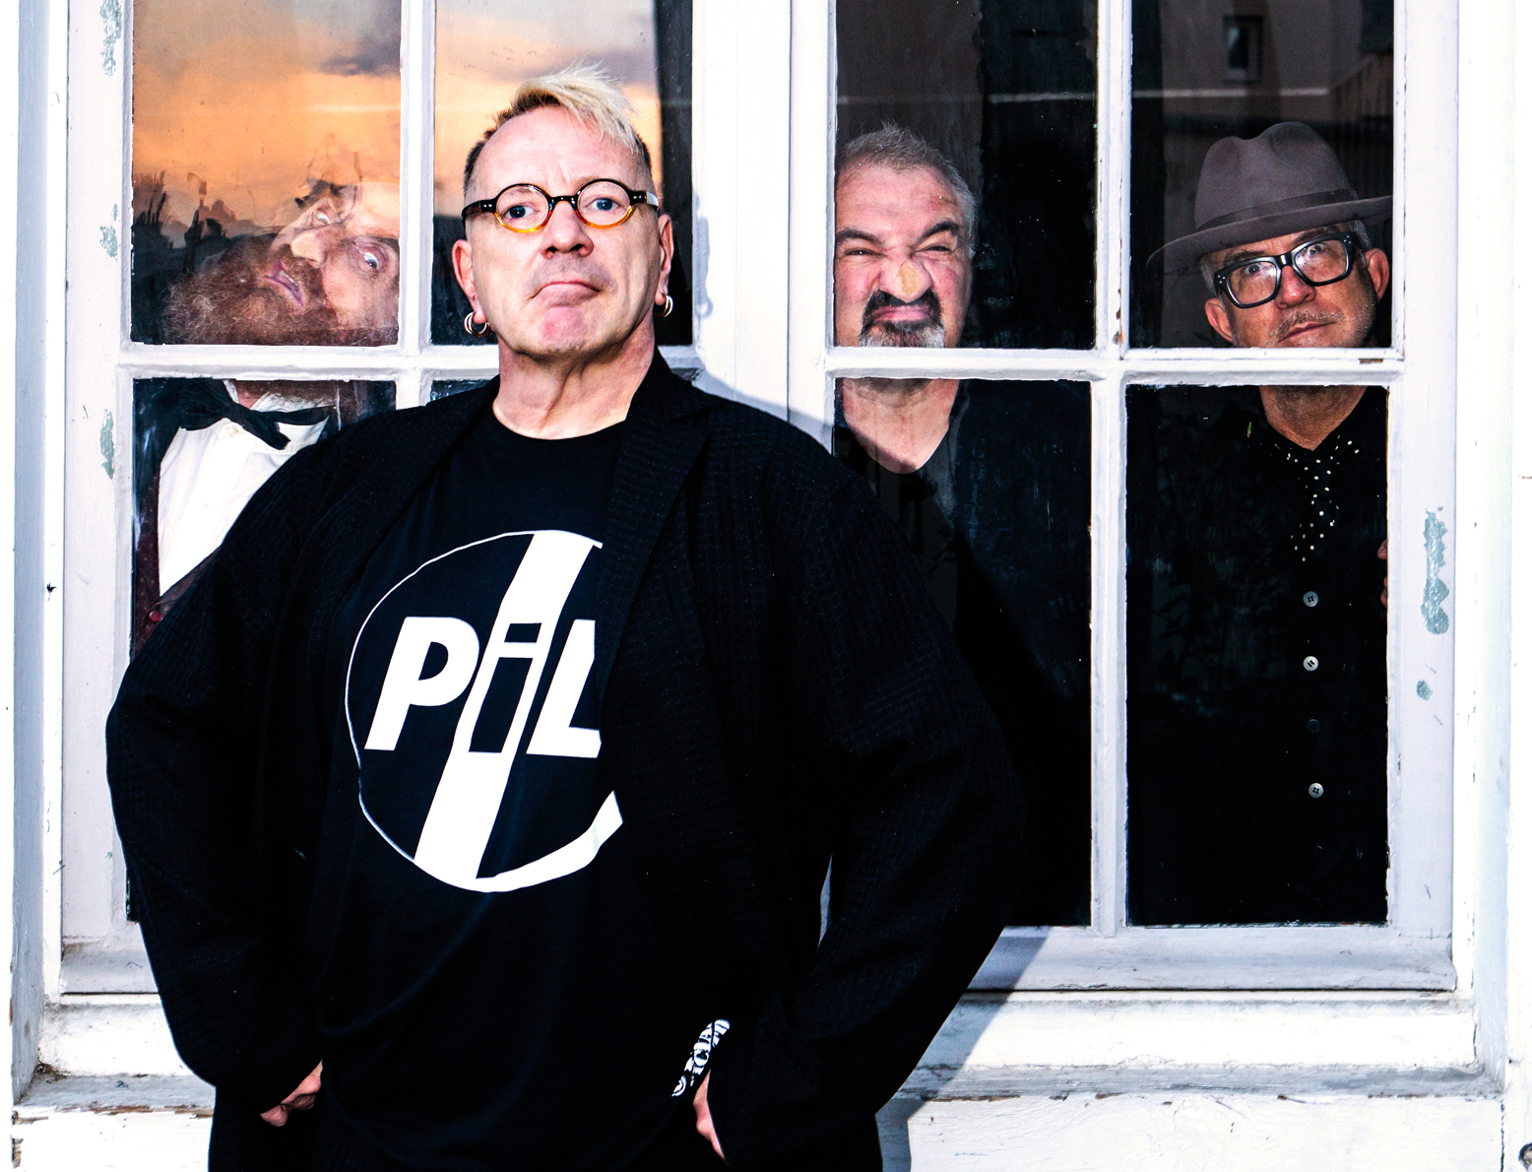
(left to right) Lu Edmonds, John Lydon, Scott Firth, Bruce Smith (photo Tomohiro Noritsune) © PiL Official 2015

Tickets go on general sale at 9am on Monday, January 18th, preceded by a pre-sale beginning at 9am on Friday, January 15th through to Monday 18th. See www.pilofficial.com for ticket links and additional information.

The 22 date tour includes a return to London’s, Indigo at 02 on Saturday, June 4th (which PiL previously sold-out in December 2014). The tour takes in festival and club shows in Spain, Germany, Slovakia, Poland and Ukraine before heading to the UK on Tuesday, May 24th for a re-arranged show at Coventry, The Copper Rooms at Warwick University.

The band will also headline the Bearded Theory Festival in Walton-on-Trent on Saturday, May 28th and play shows in Wakefield, Wrexham, Cardiff, Sunderland, Lincoln, Blackburn, Oxford and Sheffield; as well as the previously mentioned Indigo at O2 show in London.

Last year the band released their 10th studio album ‘What The World Needs Now…’ which peaked at number 29 in the official UK album charts and picked up fantastic acclaim from both press and public. (The album also peaked at number 3 in the official UK indie charts and number 4 in the official UK vinyl charts). ‘What The World Needs Now…’ was self-funded by PiL and released on their own label ‘PiL Official’ via Cargo UK Distribution.

Widely regarded as one of the most innovative and influential bands of all time, PiL’s music and vision earned them 5 UK Top 20 singles and 5 UK Top 20 albums. With a shifting line-up and unique sound, John Lydon guided the band from their debut album ‘First Issue’ in 1978 through to 1992’s ‘That What Is Not’. After a 17 year hiatus, Lydon reactivated PiL in 2009 by taking them back on the road worldwide.

John Lydon, Lu Edmonds, Scott Firth and Bruce Smith continue as PiL. They are the longest stable line-up in the band's history.

Public Image Ltd:

John Lydon - After fronting the Sex Pistols, John Lydon formed Public Image Ltd in 1978. Outside of PiL John has released several solo records and collaborations. He also brings quality TV to the masses and has recently released the autobiography ‘Anger is an Energy: My Life Uncensored’.

Lu Edmonds - Multi instrumentalist and former guitarist in The Damned, Lu joined PiL in 1986 recording and playing on the album ‘Happy?’ and co-writing the album ‘9’, adding yet another dimension to the PiL sound.

Bruce Smith - Drummer in The Pop Group and formerly of The Slits Bruce became percussionist for PiL in 1986 playing and recording on the albums ‘Happy?’ and ‘9’. Seen as a drumming virtuoso, Bruce brought his unique style into the fold.

Scott Firth - A bass player/multi instrumentalist that has collaborated and played with a variety of top musicians and bands including Steve Winwood, John Martyn and Elvis Costello.

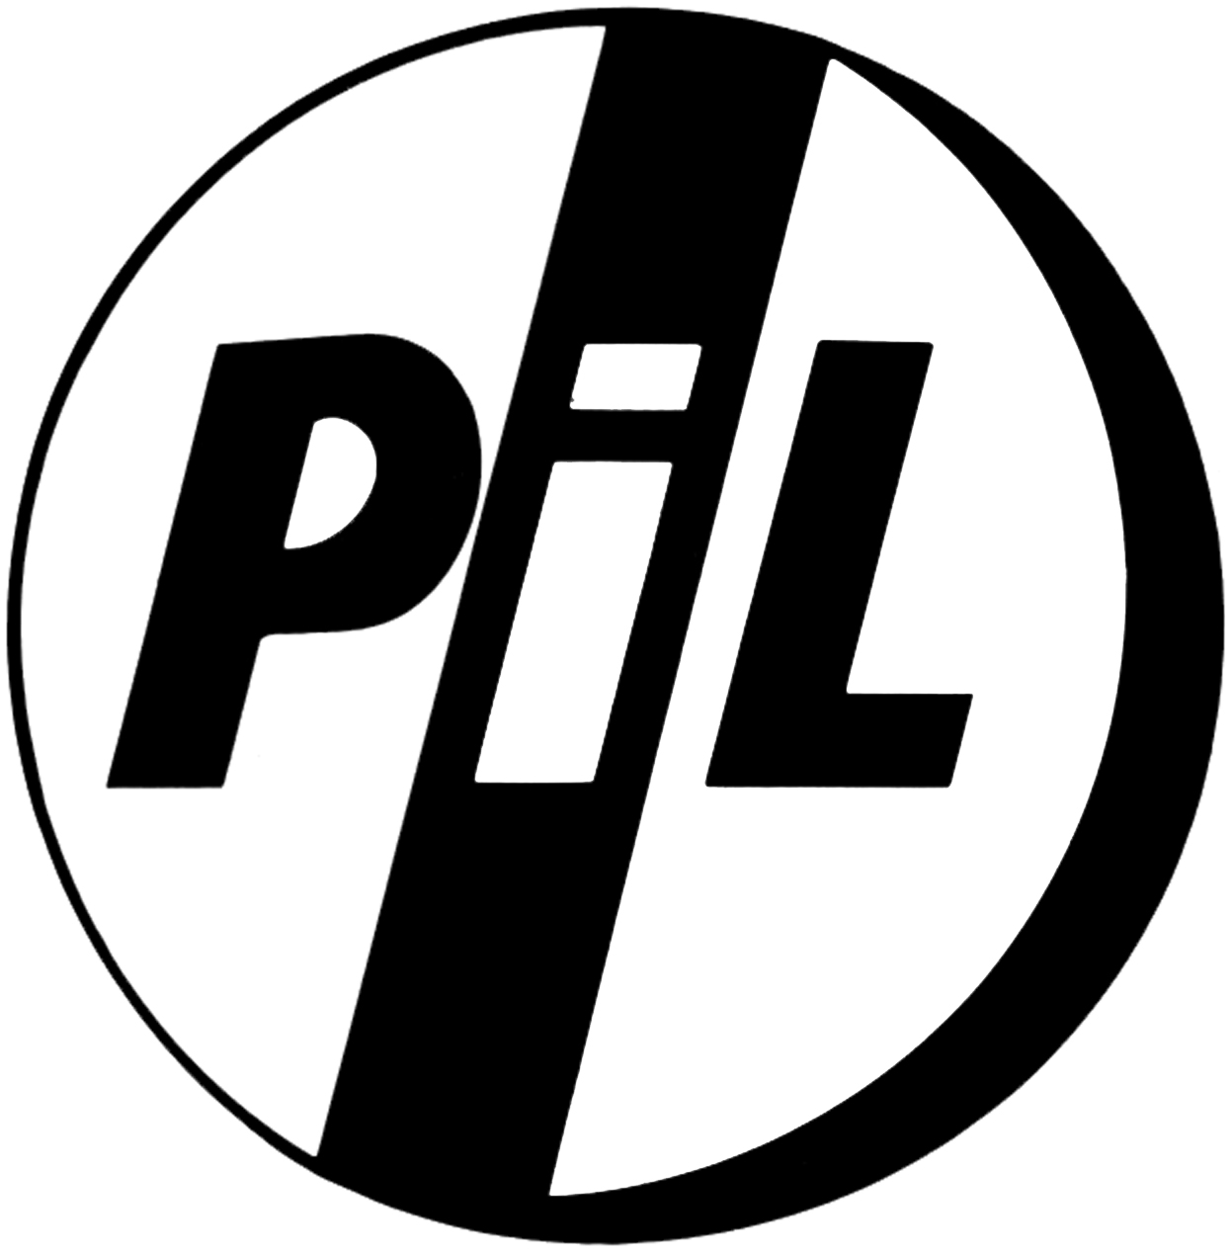

European Tour Dates
Valencia, Noize Club, Spain, Friday, May 6th 2016
Santander, Escenario, Spain, Saturday, May 7th 2016
Madrid, Joy Eslava, Spain, Sunday, May 8th 2016
Wiesbaden, Schlachtof, Germany, Tuesday, May 10th 2016
Dusseldorf, Zakk, Germany, Wednesday, May 11th 2016
Hamburg, Markthalle, Germany, Thursday, May 12th 2016
Berlin, Huxleys, Germany, Saturday, May 14th 2016
Bratislava, MMC, Slovakia, Tuesday, May 17th 2016
Warsaw, Proxima, Poland, Wednesday, May 18th 2016
Kiev, Club Atlas, Ukraine, Friday, May 20th 2016
Kharkiv, Cinema Concert Hall (KKZ), Ukraine, Saturday, May 21st 2016

UK Tour Dates
Coventry, The Copper Rooms @ Warwick University, UK, Tuesday, May 24th 2016
Wakefield, Warehouse 23, UK, Wednesday, May 25th 2016
Wrexham, William Aston Hall, UK, Thursday, May 26th 2016
Walton-On-Trent, Bearded Theory Festival, Saturday, May 28th 2016
Cardiff, Tramshed, UK, Sunday, May 29th 2016
Sunderland, The Point, UK, Monday, May 30th 2016
Lincoln, Engine Shed, UK, Wednesday, June 1st 2016
Blackburn, King George's Hall, UK, Thursday, June 2nd 2016
London, Indigo at O2, UK, Saturday, June 4th 2016
Oxford, O2 Academy, UK, Monday, June 6th 2016
Sheffield, O2 Academy, UK, Tuesday, June 7th 2016

For further information please contact Kevin Pocklington on +44 7952 493621 or email kevin@jennybrownassociates.com

www.pilofficial.com | www.facebook.com/pilofficial | www.youtube.com/pilofficial |
www.twitter.com/pilofficial (@pilofficial) | www.instagram.com/pilofficial

