Introducing Tatum, the 18-year-old dark pop singer you’ll be hard-pressed to forget

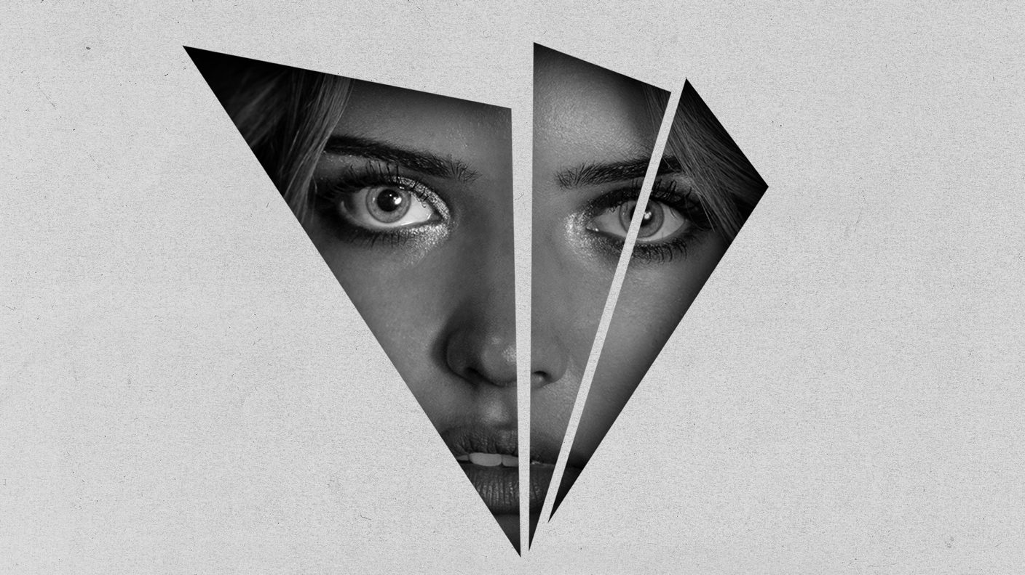

(Photos are attached)

Tatum’s debut single “Broken” is a moody, broody ballad and a consuming coming of age.
From the intense opening line of Tatum’s debut single “Broken” the 18-year-old singer immediately throws down the gauntlet and you feel it instantly.
Her voice smacks of the languid romanticism of Lana Del Rey and the moody phrasing of Lorde, and it’s steeped in dream pop lashings and an emotional depth that’s far beyond her young years.
Despite her age, Tatum already knows exactly who she is, refuting any manufactured bubble-gum pop sheen in favour of telling her own authentic truth with her debut single.
"Sometimes there is poignant beauty in broken things. Broken beings have often survived a lot and have a much greater depth. I consider myself broken in many ways too and when it comes to love I prefer broken people because just like the process of purifying gold through fire, perfection for me only comes after pain and dark times, after being broken many times,” Tatum confesses when asked about the underlying narrative of her debut single.
Fate brought her to the attention of indie label Bad Future Records, who, just like Tatum, share the same outlook on reinforcing her artistic authenticity, alongside songwriter Mia Van Wyk (Bad Future, Hunter As A Horse) “Broken” is a flawless exhibition of that truth.

“This song is about first real love and heartbreak. It’s a coming-of-age story between two young lovers that leaves them broken but also acquainted with the great beauty of love for the first time. They are star-crossed and the relationship will almost certainly end just like the world will. They both lose their innocence in love but also life. A sort of fatalistic view of the world is born out of this broken and beautiful love,” Mia Van Wyk adds to the truth-telling of this passionate narrative.
Tatum is a rare talent, one that comes along only every so often to captivate and mesmerize with her old school aesthetic and momentous lyrics.
Stream “Broken” on all platforms:
Tatum Links:

Facebook - https://www.facebook.com/Tatumsounds/
Instagram - https://www.instagram.com/tatum_strydom/
Soundcloud - https://soundcloud.com/tatumsounds

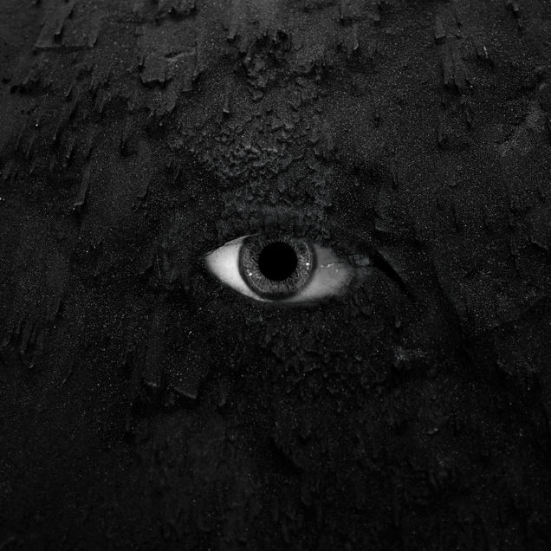
“Broken” artwork by Kyle Keminc

