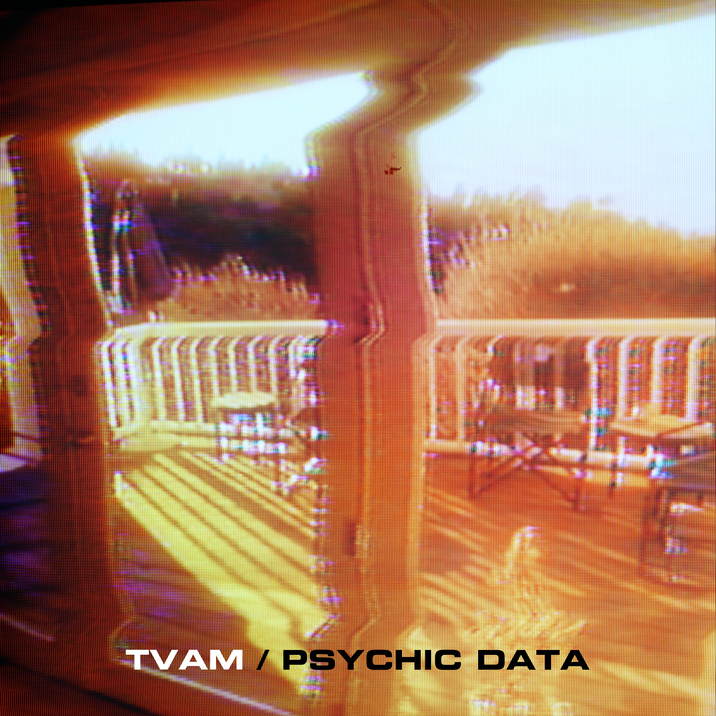
TVAM announces new single ‘PSYCHIC DATA’ - for release 11th April 2018

Watch the video to ‘PSYCHIC DATA’ here:

https://www.youtube.com/watch?v=1g06-CP9vmA&feature=youtu.be

Under the guise of TVAM, producer Joe Oxley returns with a portion of modern-day paranoia. It is in PSYCHIC DATA he seeks to define everything from
abandoned meanings to subconscious desires; a world in which information seeps under your door and pools by your feet. You’ll let it in, under your skin.

A Cronenberg body-horror where guitar refrains are beamed from the highest telecoms tower and vocals swoon like a siren-call for the disenfranchised. With juddering rhythms, warping basslines and melodies which melt like a Calippo on hot concrete, TVAM delivers his message straight to the subconscious.
Mixed by the steady hands of master Dean Honer (Moonlandingz, I Monster, Add (N) To X), the machine is made flesh.

Somewhere within a lifetime of repeats, reruns and reboots, TVAM lives, crafting sounds and visuals which touch on our memories but toy with our fears. A world in which broadcast becomes performance.

Hypnotic tracks which straddle an impressive spectrum of influence; with Boards of Canada’s irresistible nostalgia, Suicide’s deconstructed rock’n’roll and MBV’s infinite noise all becoming touching points in Oxley’s musical output.

Shining a harsh light on our nostalgia, TVAM’s live show is something of a
spectacle. Blurring the line between art and performance, Oxley is aided by long-dead technology and haunted sloganeering to broadcast his self-styled psychic data. Toying with the power of influence, TVAM offers no comfort in this age of unease.

LIVE

27th April – White Hotel, Manchester (w/ Clinic)

5th May - Castle & Falcom , Birmingham (w/ Pinkshinyultrablast)
8th May - Thekla , Bristol (w/ Pinkshinyultrablast)
10th May - Tufnell Park Dome, London (w/ Pinkshinyultrablast)
19th May - JT Soar, Nottingham (w/ Birdstriking)

https://en-gb.facebook.com/tvamofficial
https://twitter.com/_tvam
https://www.instagram.com/_tvam
https://tvamindustries.com
https://soundcloud.com/tvam

For further information contact:Steve Phillips (national press)/ Matt Fogg (online)
Carry On Press 0207 095 1100 / steve@carryonpress.co.uk

