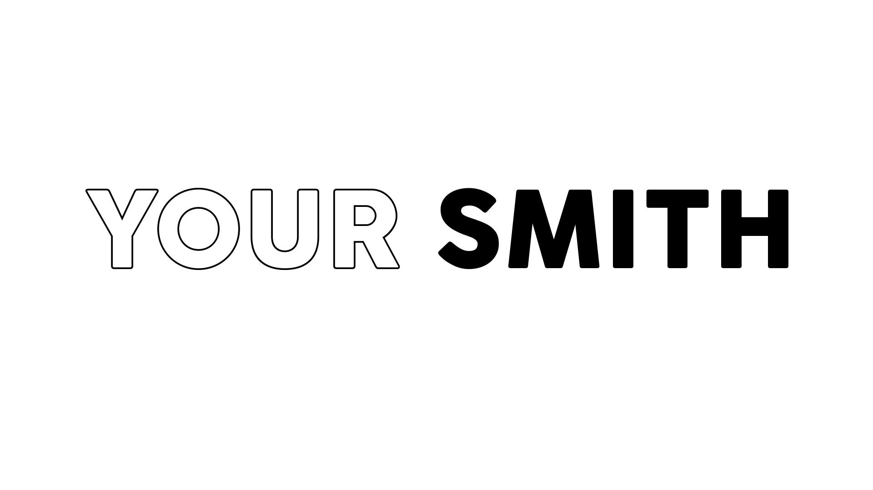

Minneapolis native Your Smith (aka Caroline Smith), relocated to Los Angeles after signing to Pulse Recording (DRAM, Miike Snow, Gallant, et. al). Inspired by the history of Laurel Canyon and moving through a city that’s been immortalized in music throughout the ages, Smith concocted her own sound, bringing together the funk / R&B “Minneapolis Sound” of her roots and the classic songwriting of the LA folk heroes.

Your Smith released her debut EP Bad Habit, in August 2018 on Neon Gold Records (HAIM, Christine & The Queens, et. al) and concluded a US headline tour in September followed by international dates supporting RHYE in winter 2019.

She has resumed collaborating with producer Tommy English (BØRNS, Kacey Musgraves) as well as Alex and Alex, Captain Cuts, and Ethan Gruska (Phoebe Bridgers) to create her sophomore EP, a collection of five songs embodying the essence of a past era, but capturing the perspective of the moment and this current climate of the world.

The first track off of the upcoming EP, “Wild Wild Woman”, will debut on June 14, released on Neon Gold Records and Liberator (AUS/NZ). “This is an anthem for the wild woman that lives inside us all, begging to be let out...”

Your Smith will embark on a northeast tour with X Ambassadors in June followed by a nationwide tour supporting K Flay this fall. [please do not announce K Flay tour until 6/14/19]

